Project Documentation: AWS Static Website CI/CD Pipeline

1. Project Setup Overview

Goal: Build a CI/CD pipeline to deploy a static website (HTML, CSS, JS) on AWS.

Key AWS services used: S3, CodePipeline, CodeBuild, IAM, CloudFront, CloudWatch, SNS.

GitHub repository as the source of pipeline.

2. Prepare the Source Repository

Set up a GitHub repository to store the static website files (index.html and images). This repository will serve as the source for the CI/CD pipeline.

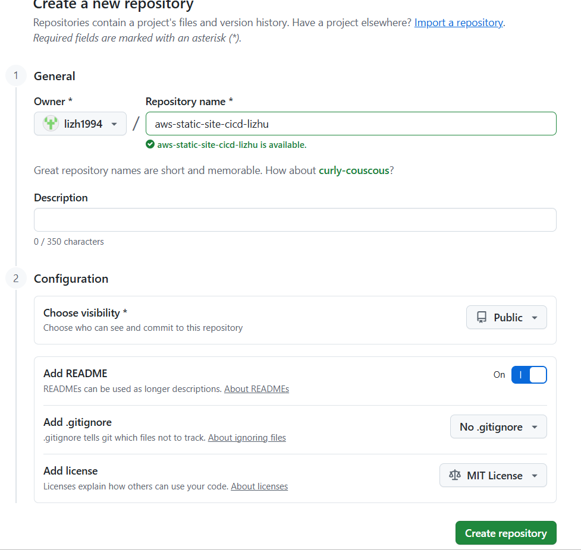

Add initial static website files (index.html, images), commit and push changes.

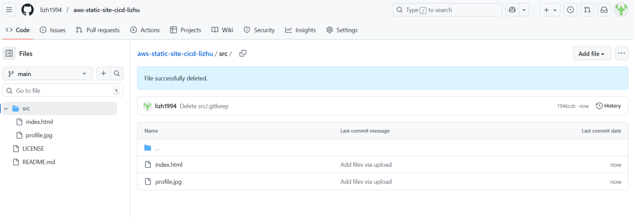

3. Create and Configure S3 Buckets

Create an S3 bucket for static website hosting.

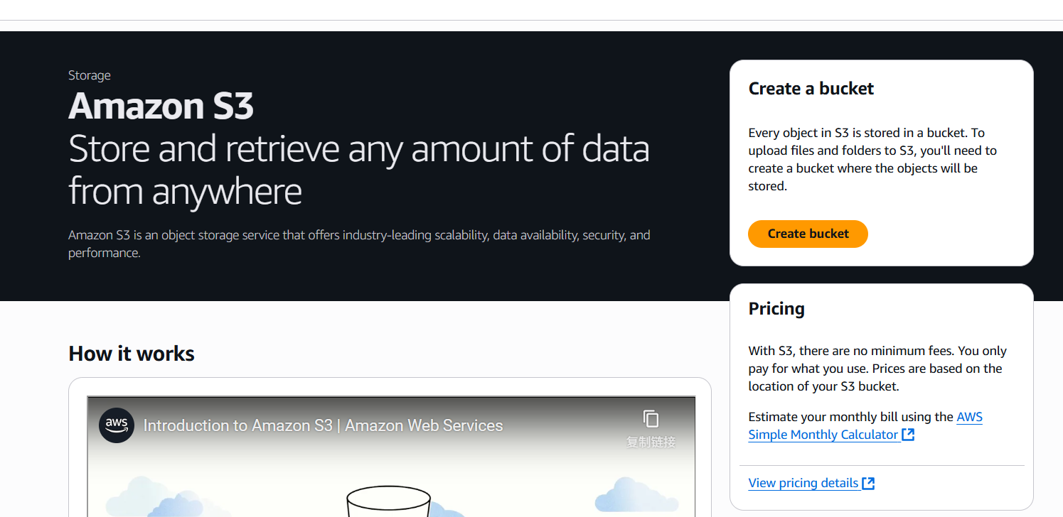

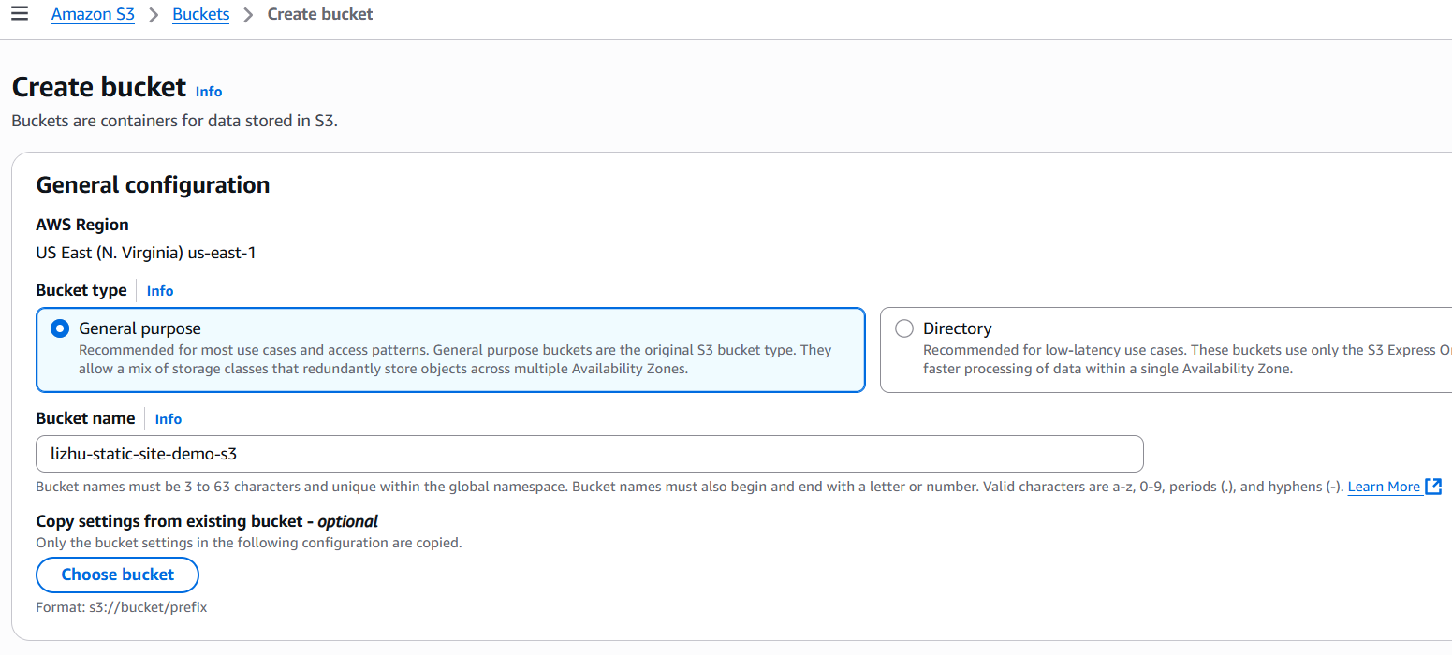

**Configuration:**

- Block Public Access: unchecked (required for static hosting).

- Versioning: enabled.

- Encryption: enabled with SSE-S3.

- Bucket Policy: restricted to s3:GetObject only to allow CloudFront access.

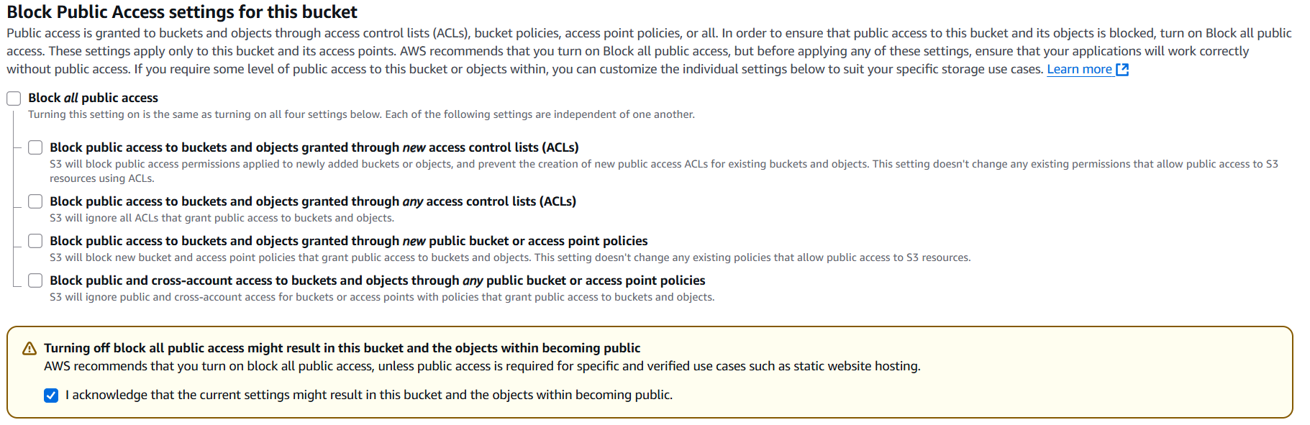

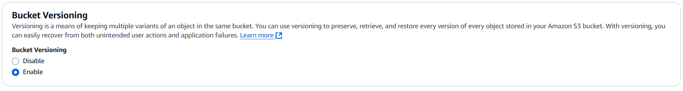

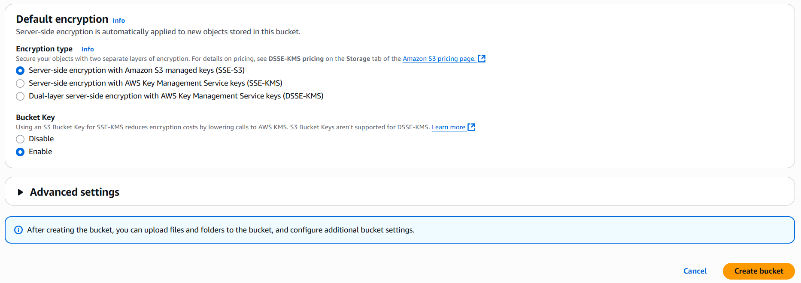

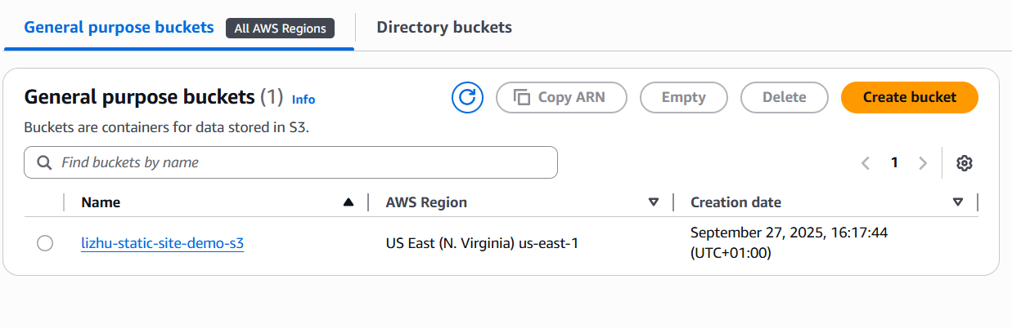

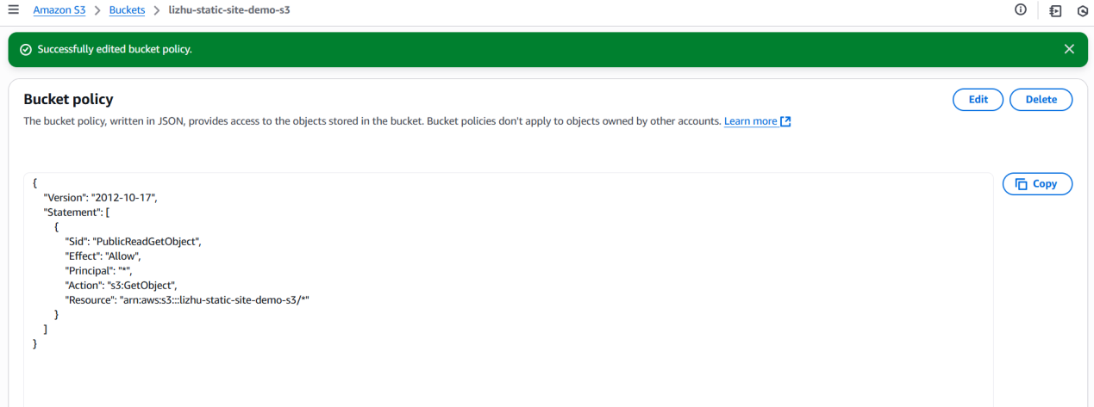

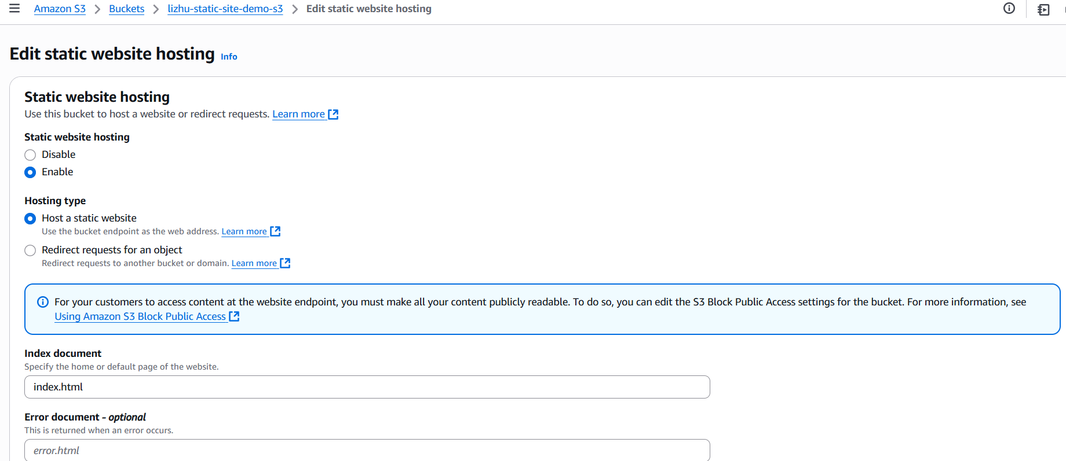

Upload the initial index.html and images, and test the static site via the S3 object URL.

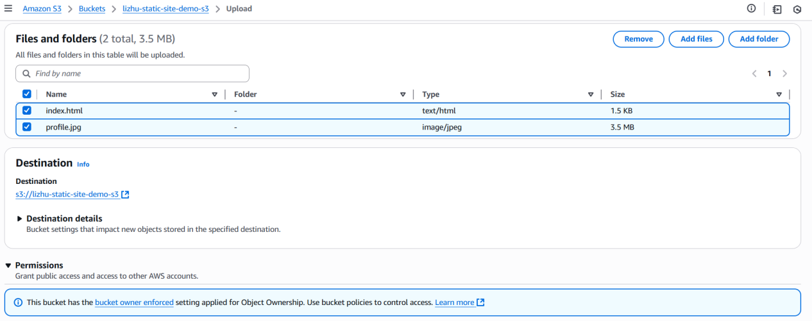

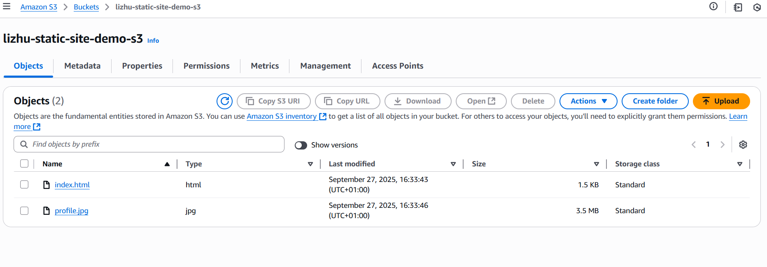

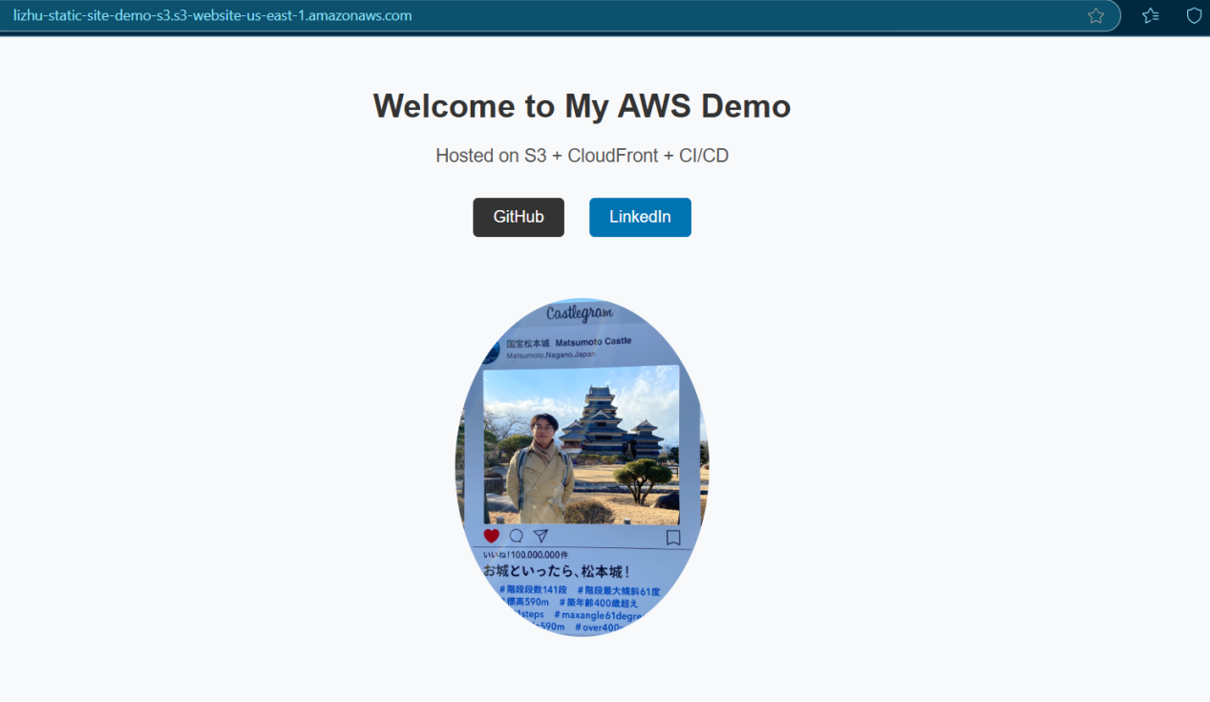

In this project, the deploy S3 bucket has a bucket policy that grants public read access (s3:GetObject) for website visitors.

At the same time, the CodeBuild IAM Role is attached with permissions to read/write/delete/list objects in the deploy bucket.

**Key Point:**

- Bucket Policy controls who (principals such as public, other accounts) can access the bucket.

- IAM Role Policy controls what the CodeBuild service itself can do.

- The final permission = intersection of both (the request must be allowed by both IAM + Bucket policy).

**Why this matters:**

This design ensures public visitors only have read access, while CodeBuild has full update capability. It’ s a clear example of IAM + Bucket Policy collaboration, aligning with the principle of least privilege.

4. Configure CloudFront Distribution and Functions

Create a CloudFront distribution with the Deploy Bucket as the origin.

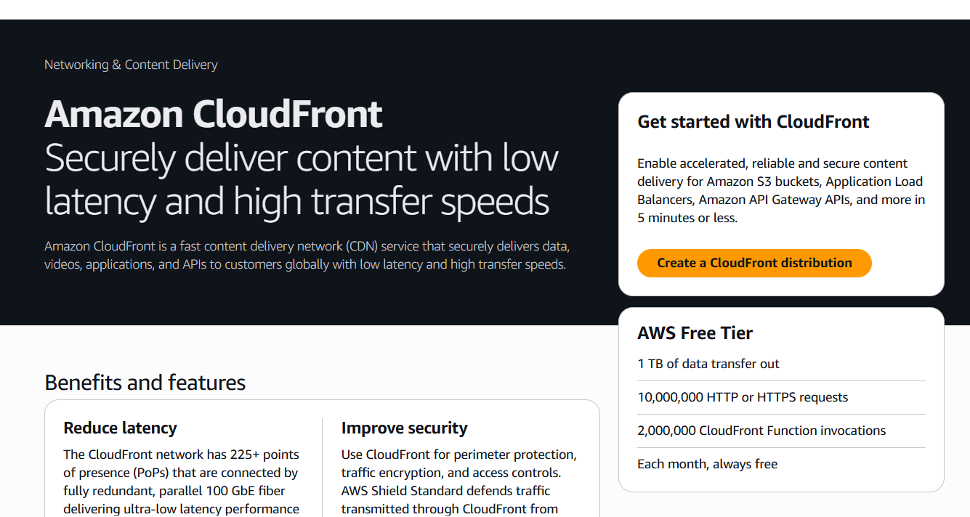

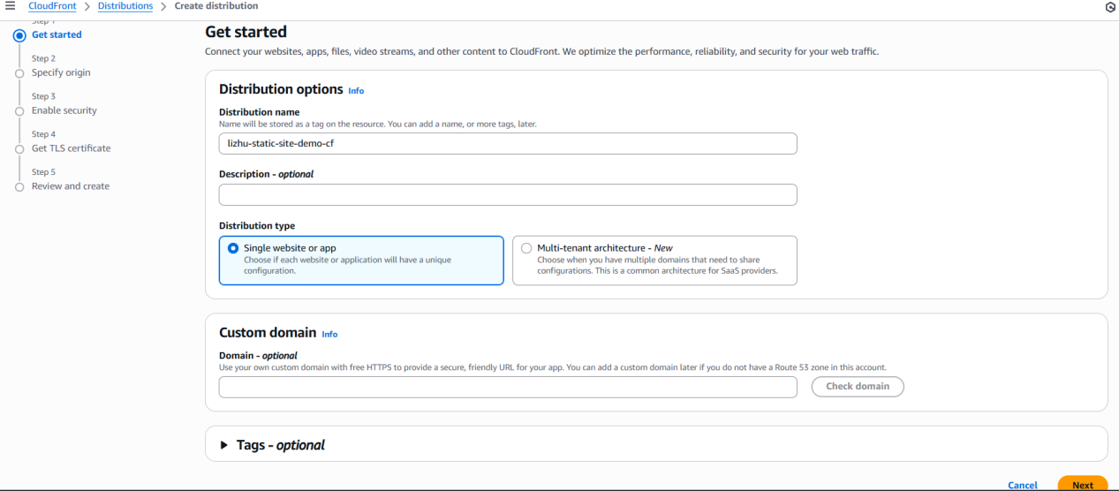

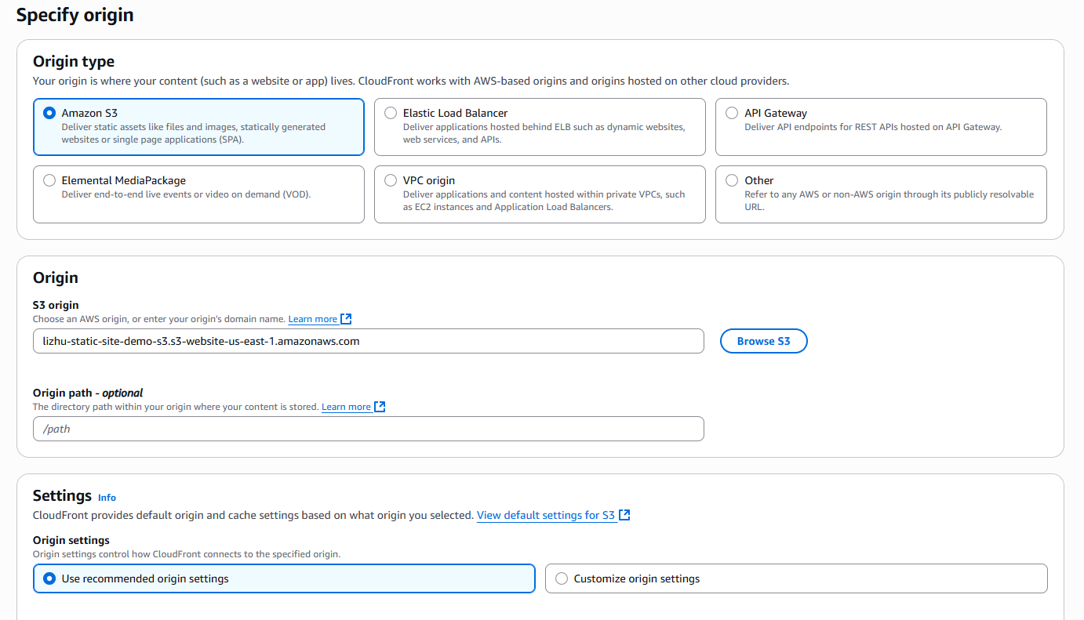

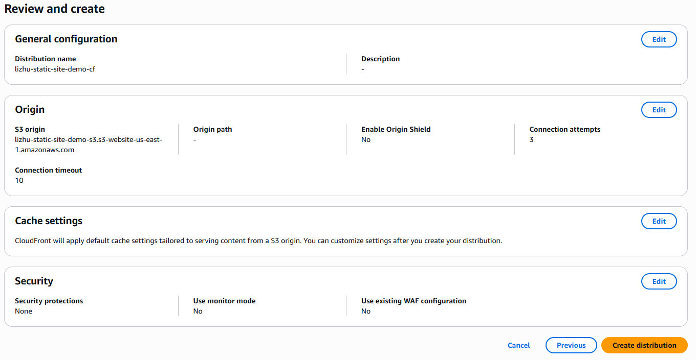

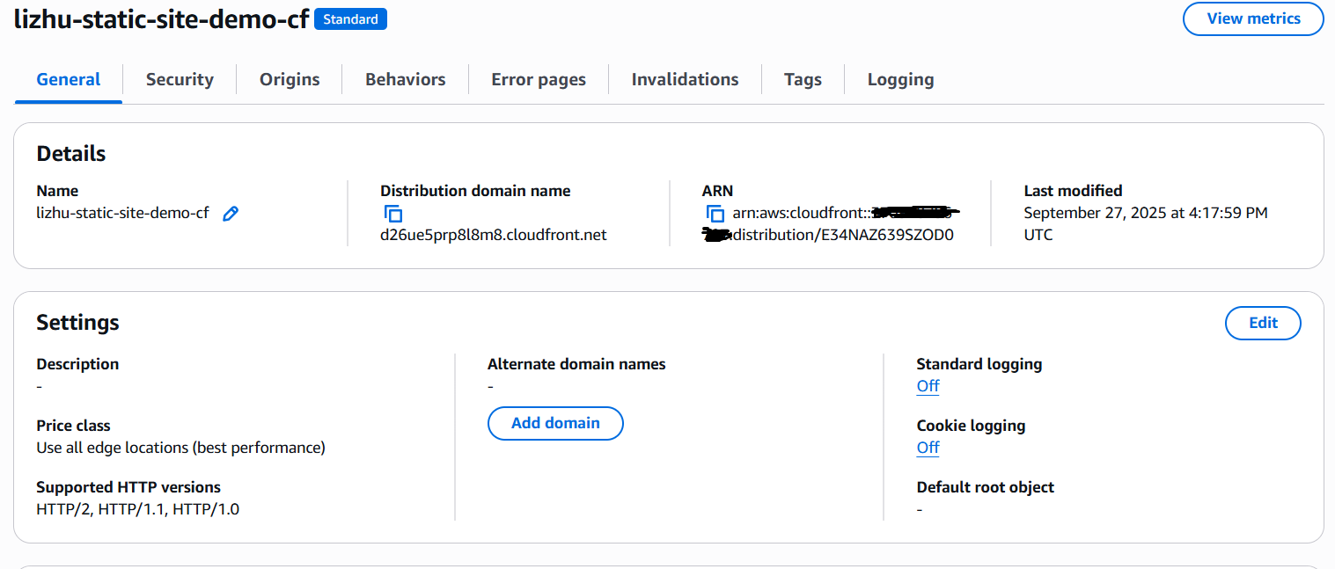

Test site access via the CloudFront distribution domain.

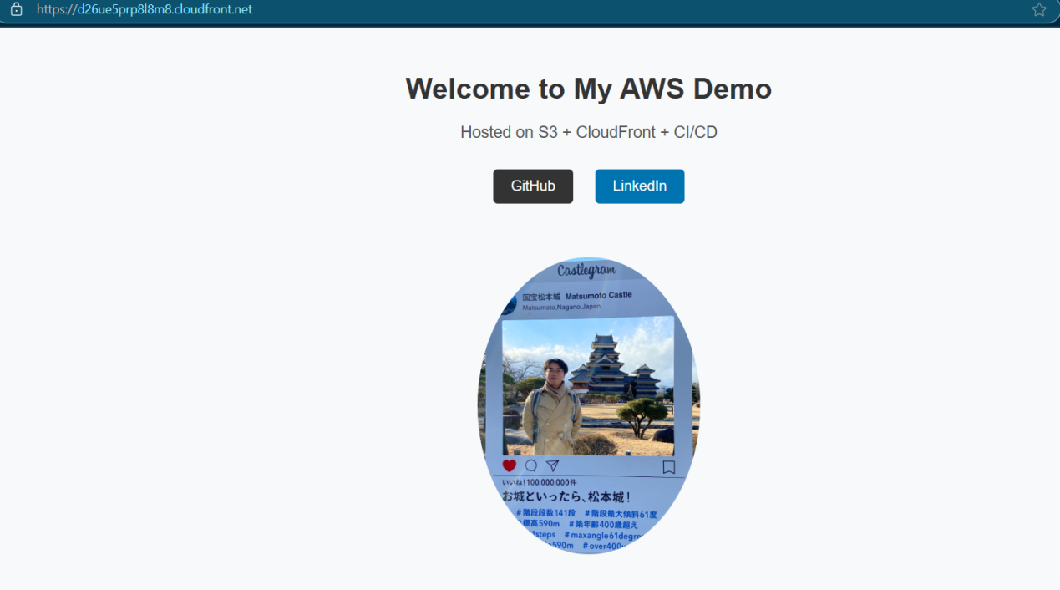

Add three CloudFront Functions:

- Path rewriting

- Simple access control

- Caching optimization

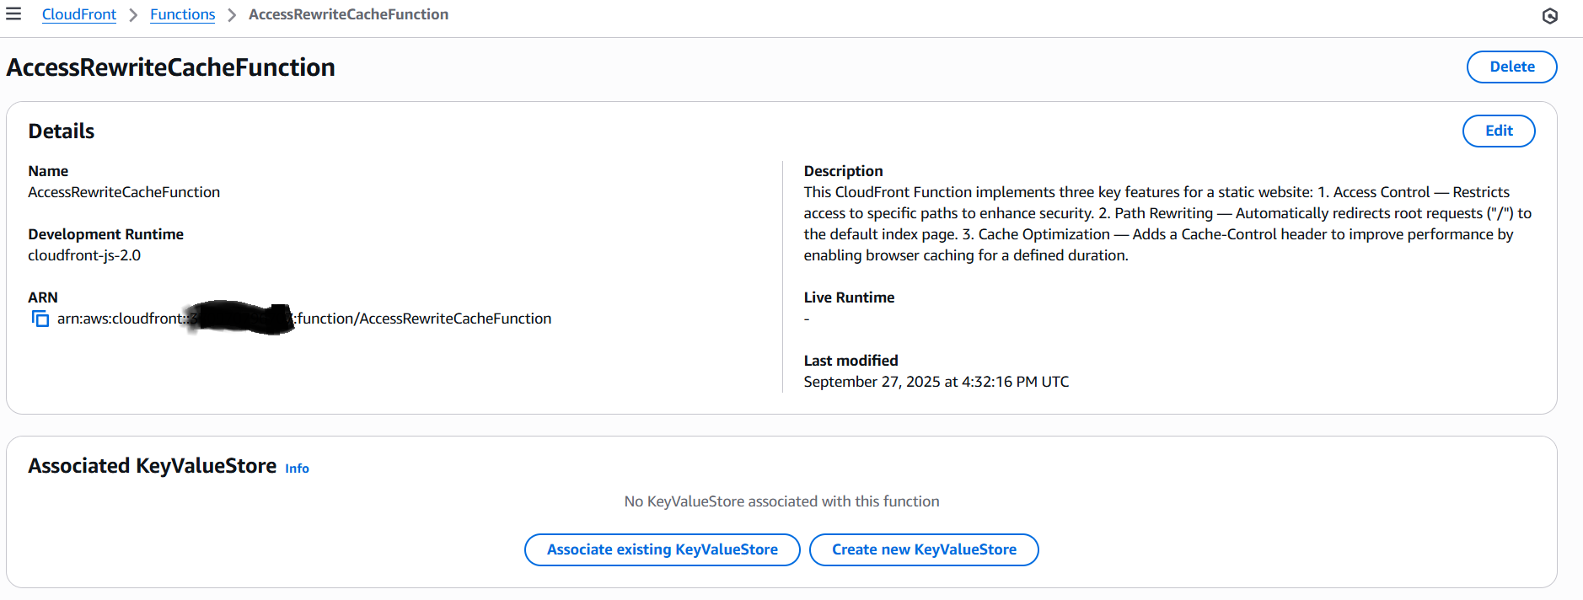

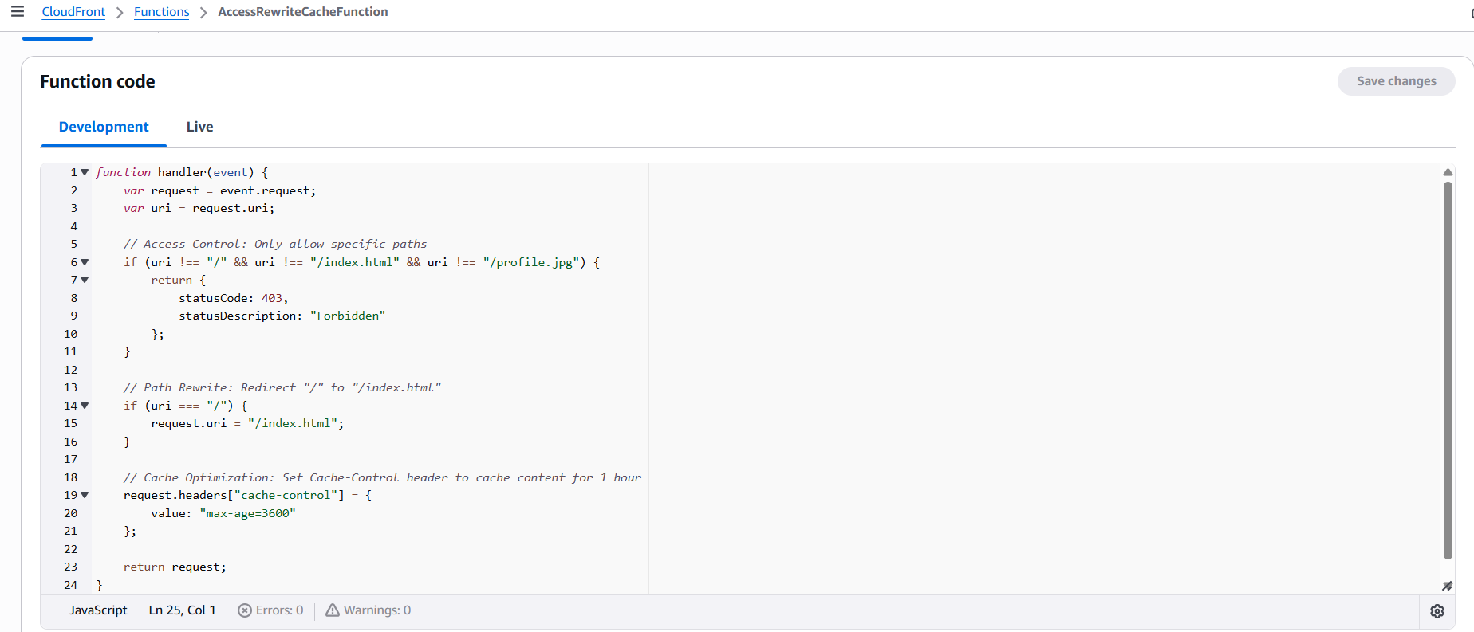

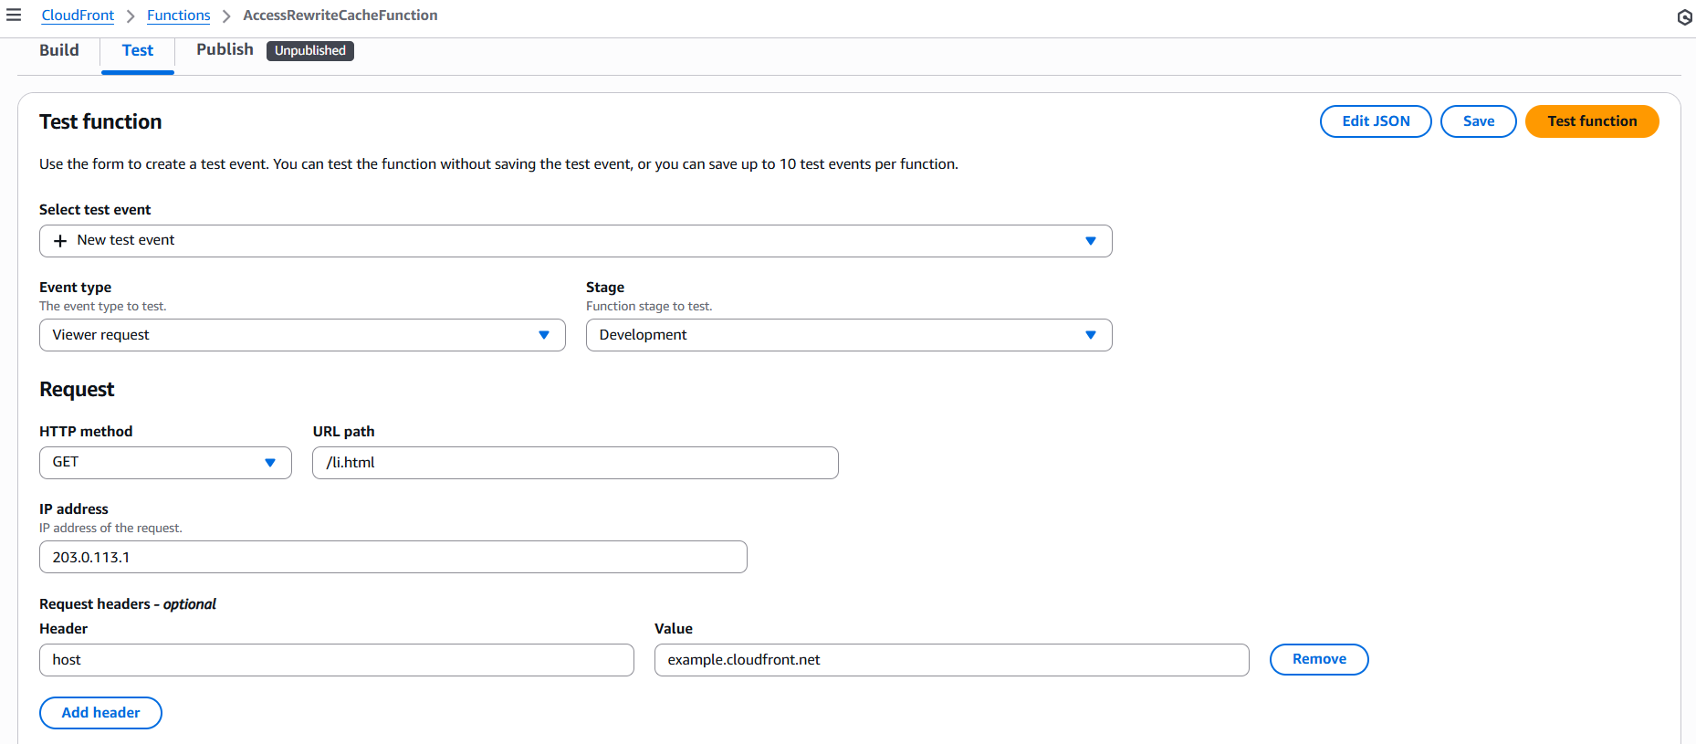

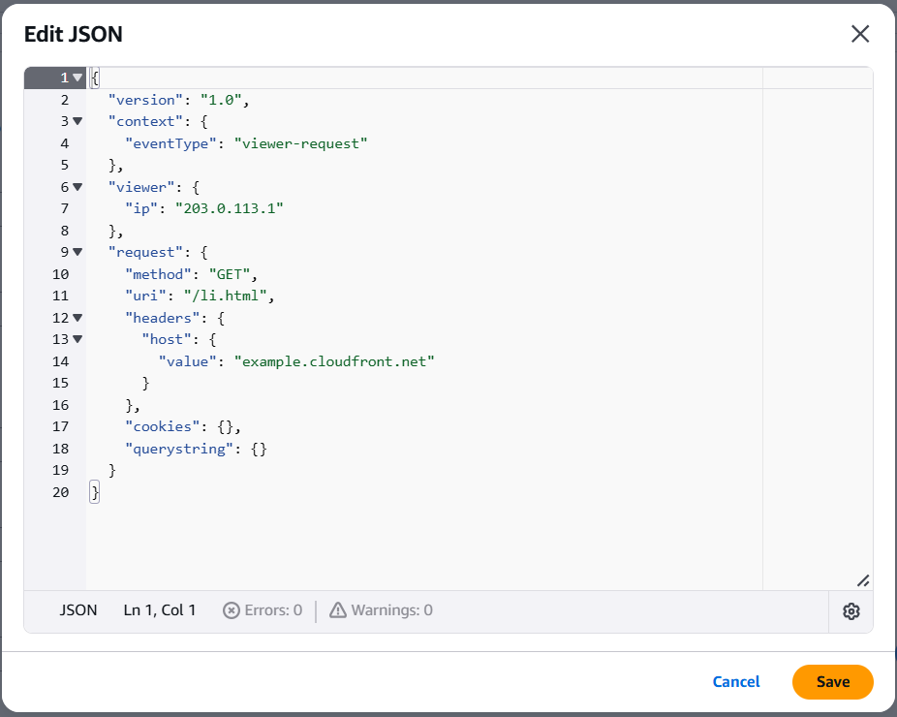

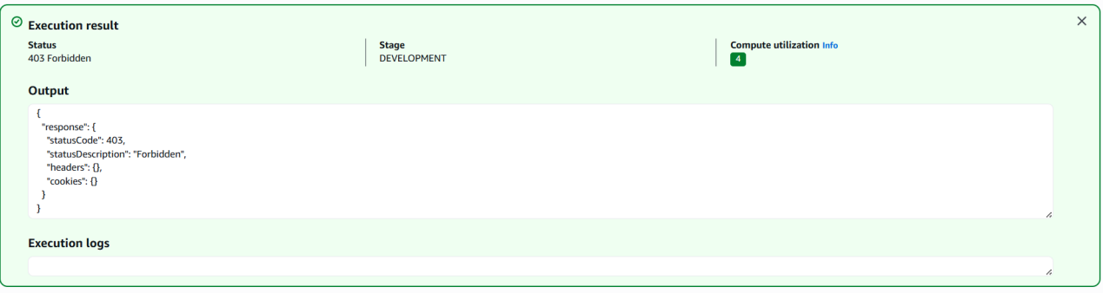

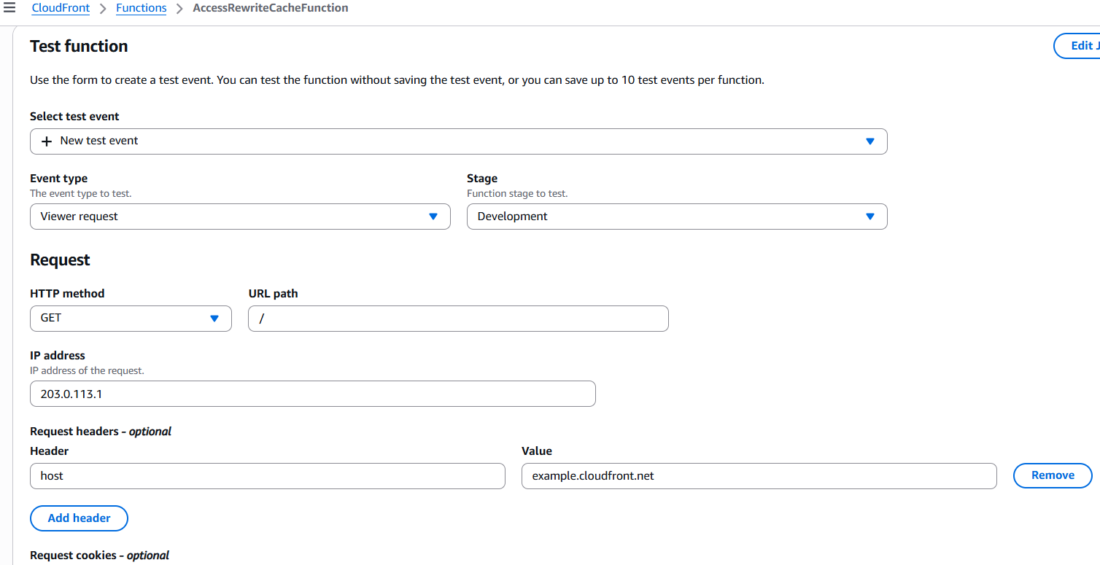

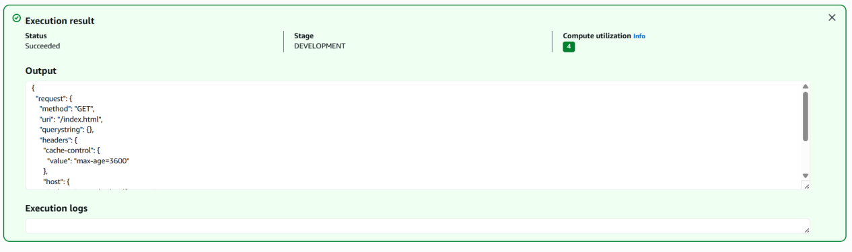

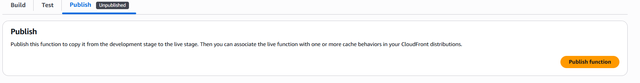

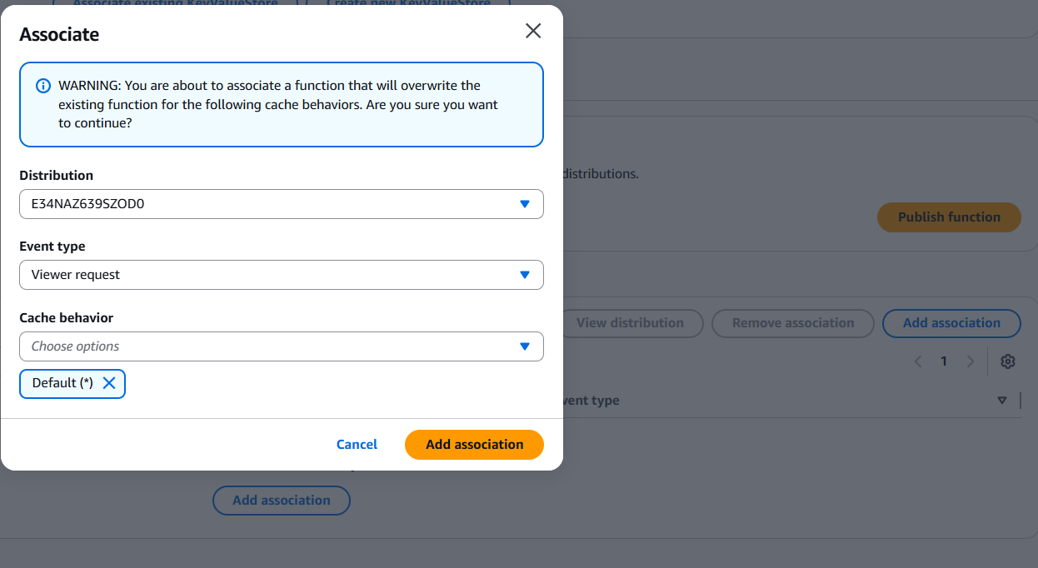

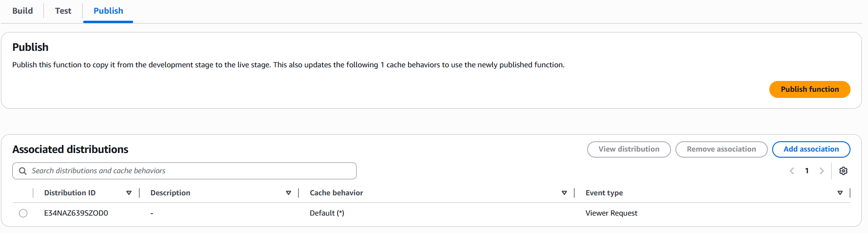

Test the function on the website

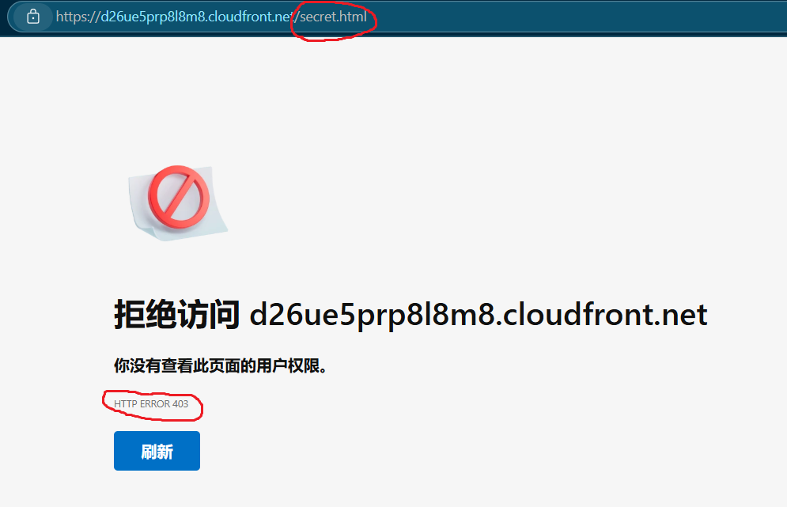

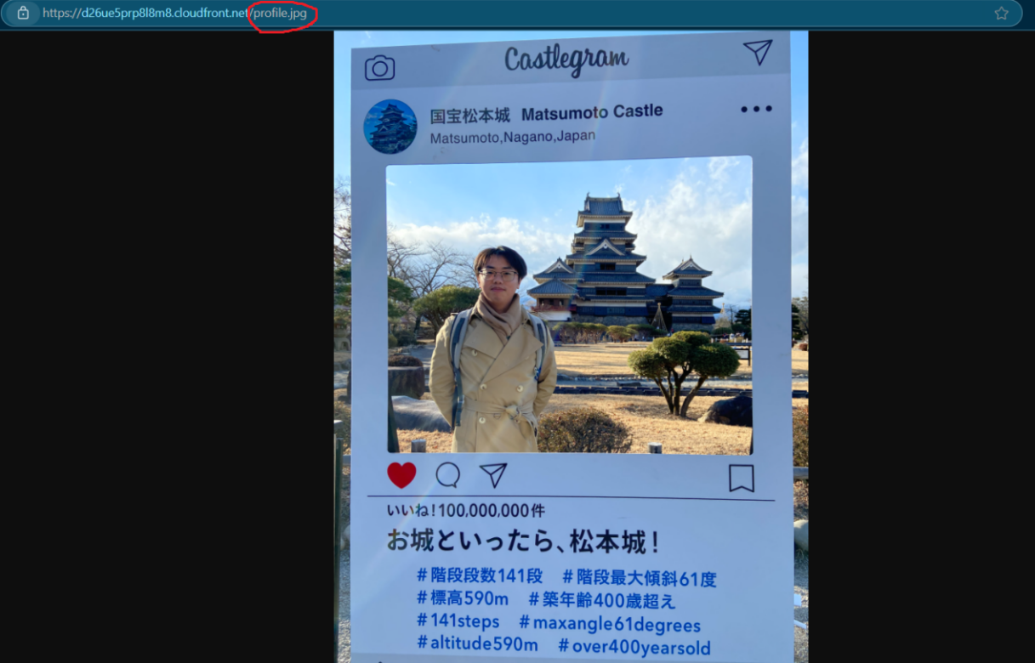

5. Create IAM Policy and CodeBuild Role

Define a custom IAM policy with least privilege permissions (read/write artifact bucket, full sync with Deploy Bucket, logging, reporting).

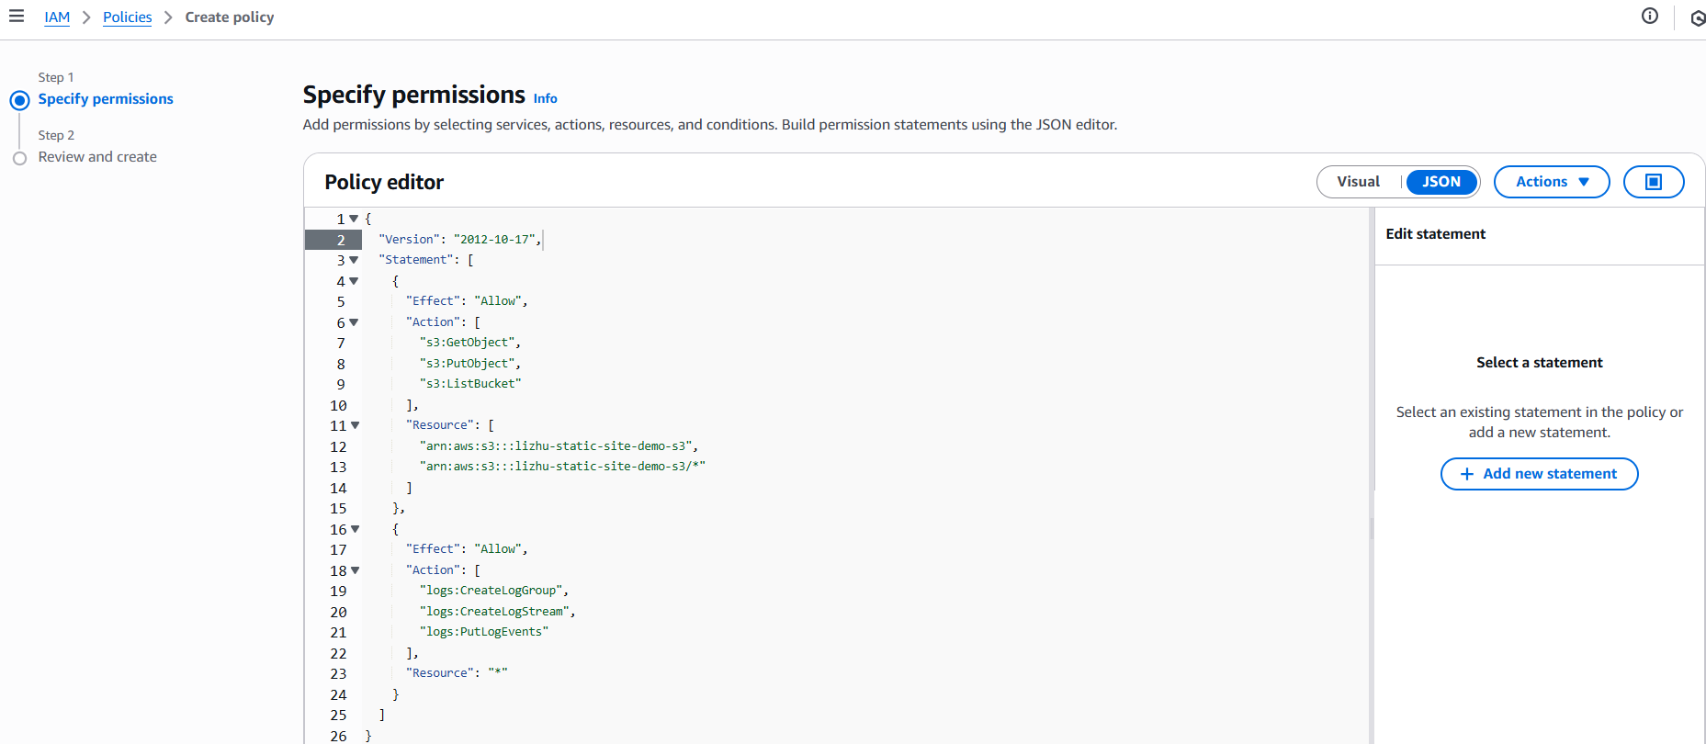

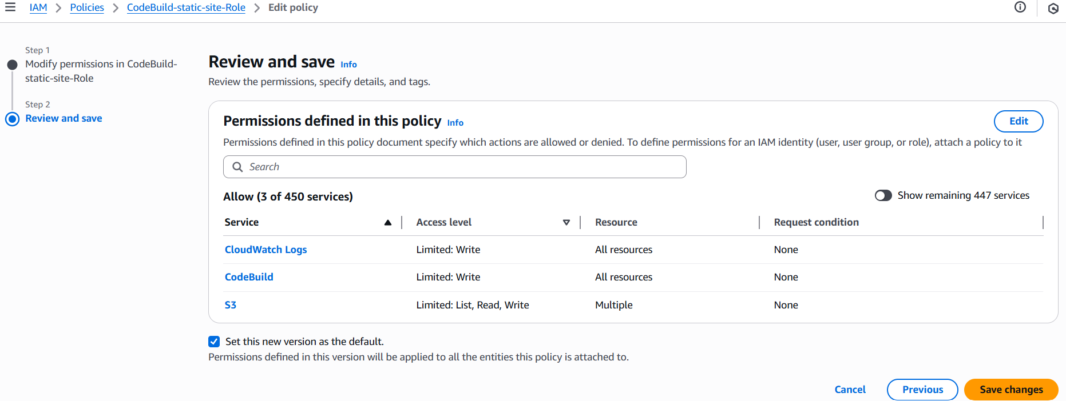

Attach the policy to a new IAM Role (CodeBuild-static-site) for use in the build process.

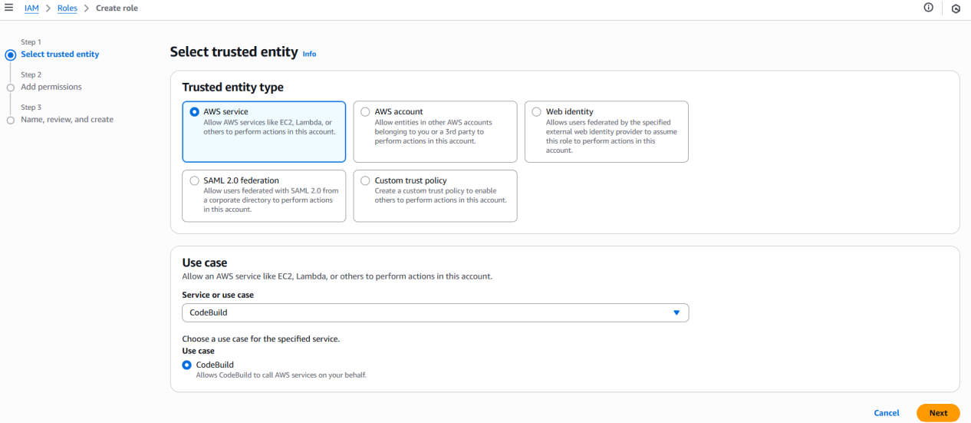

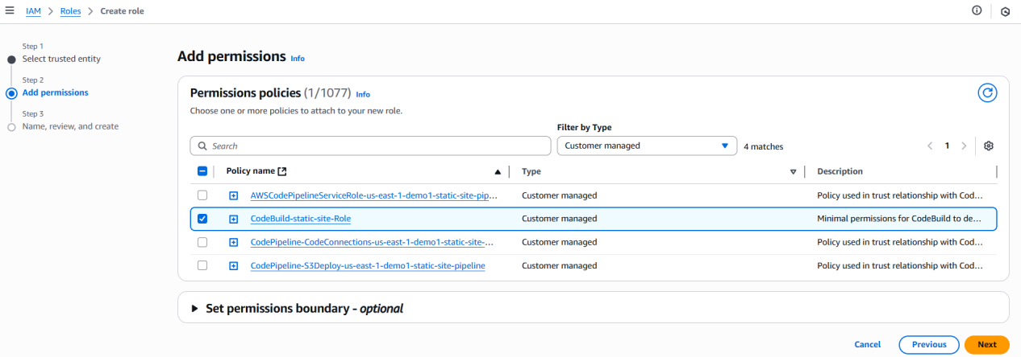

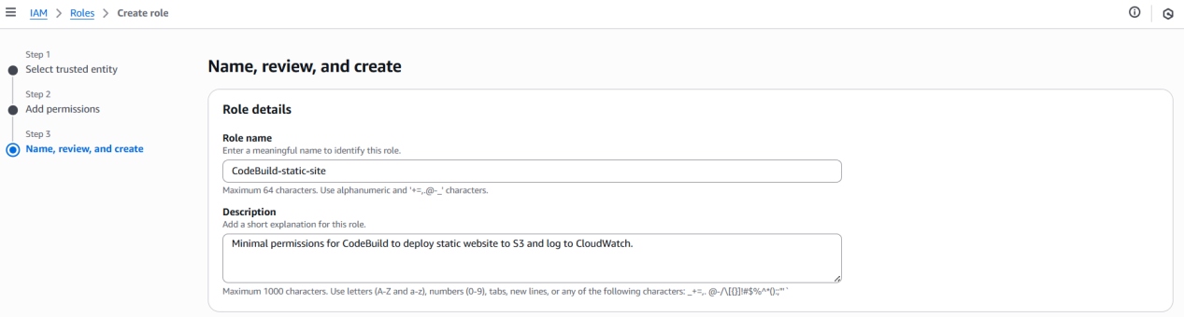

6. Create the CodeBuild Project

Create a CodeBuild project with inline build commands.

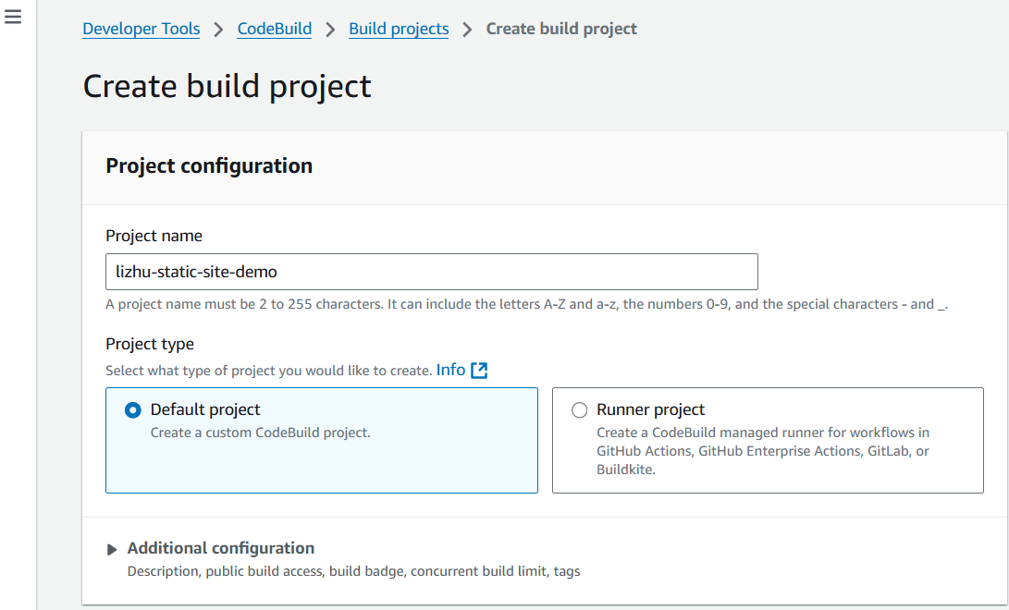

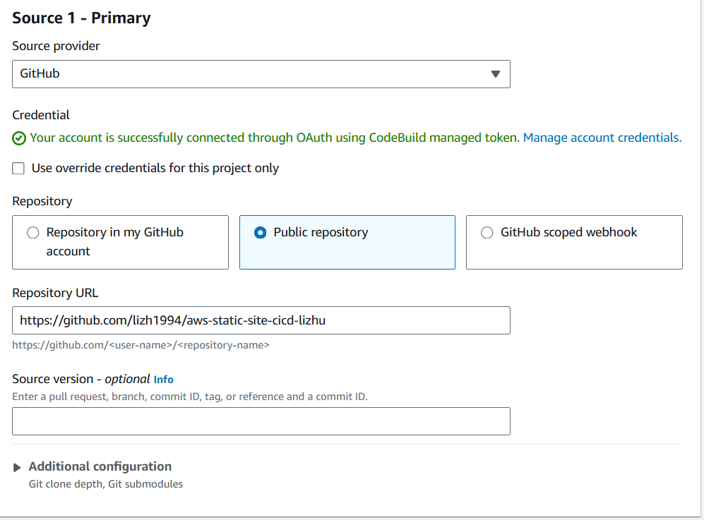

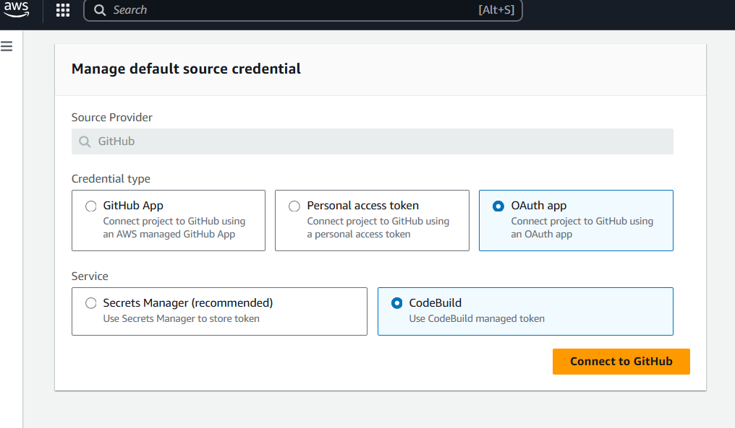

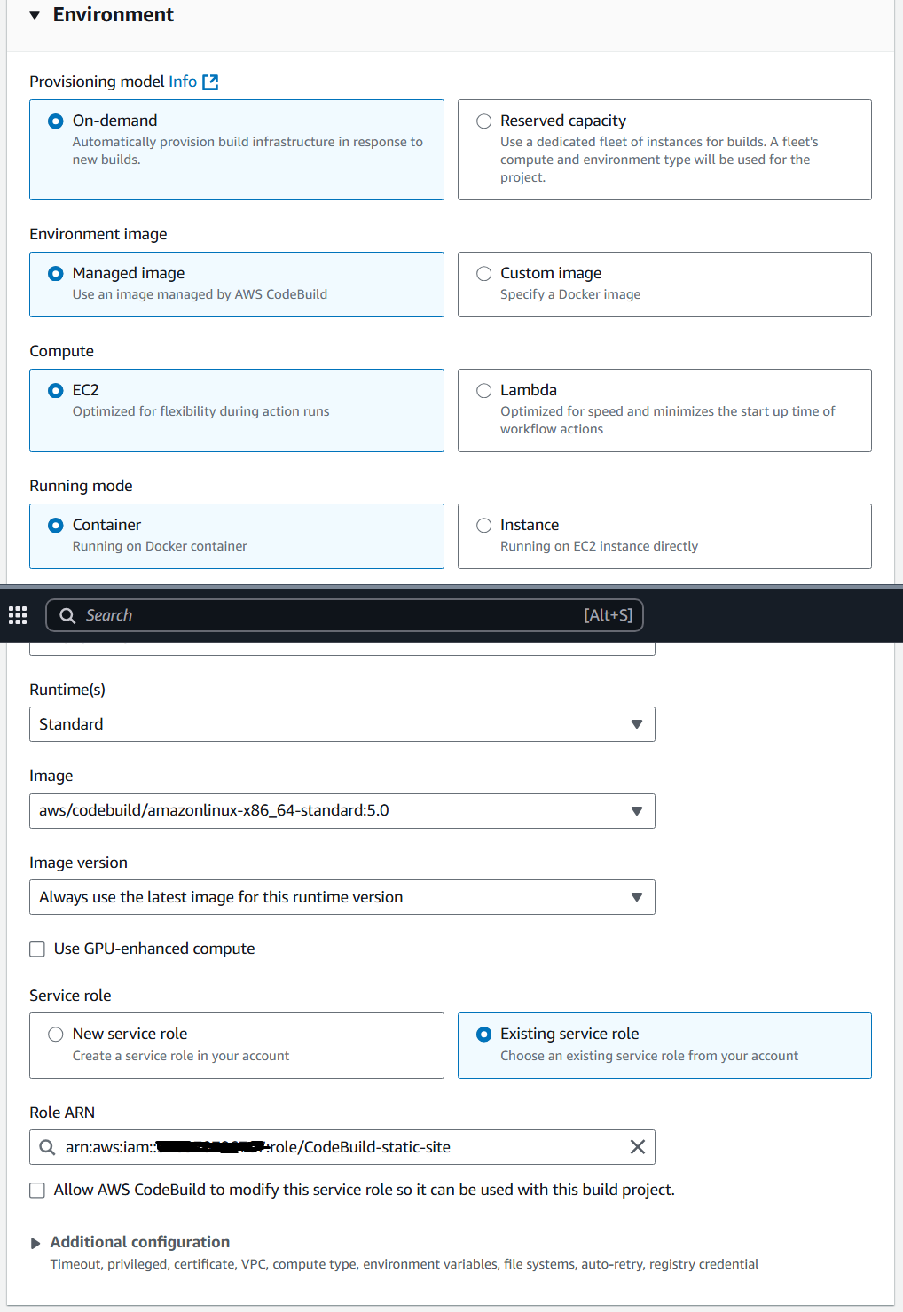

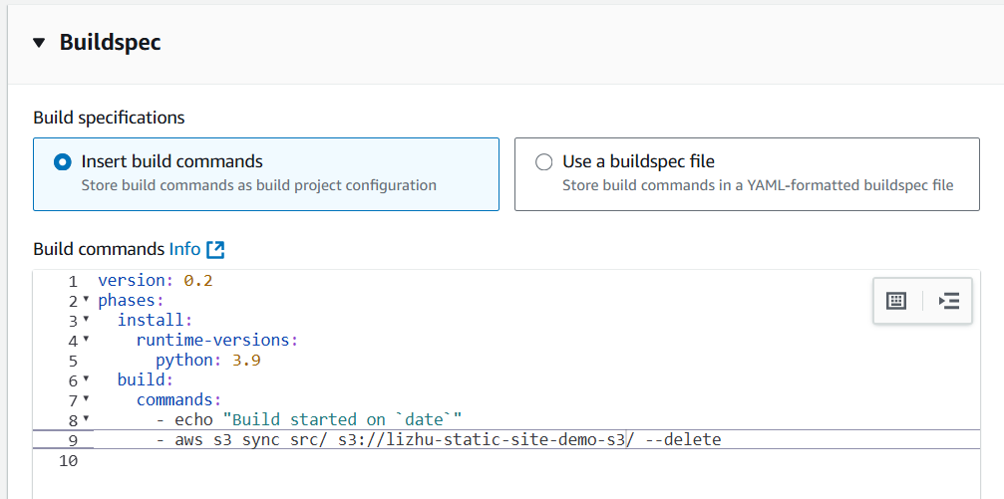

Initially, no artifact output was configured.

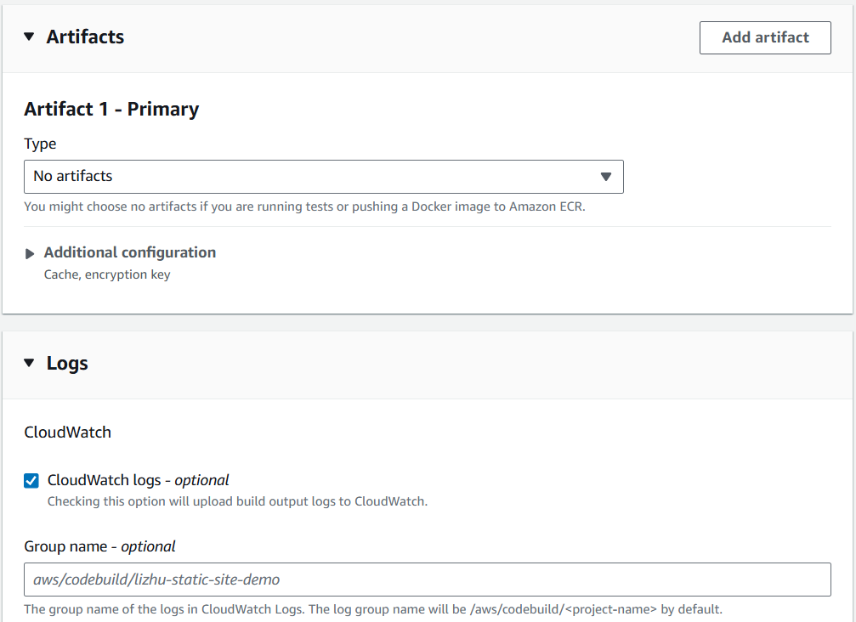

Test the build: confirmed that updated files were written to the Deploy Bucket.

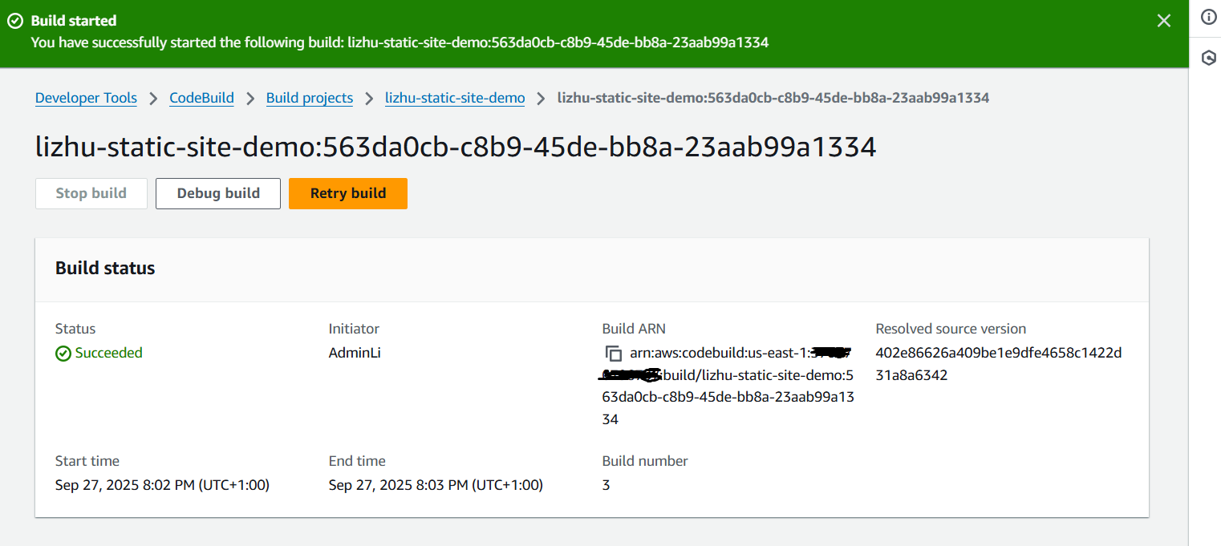

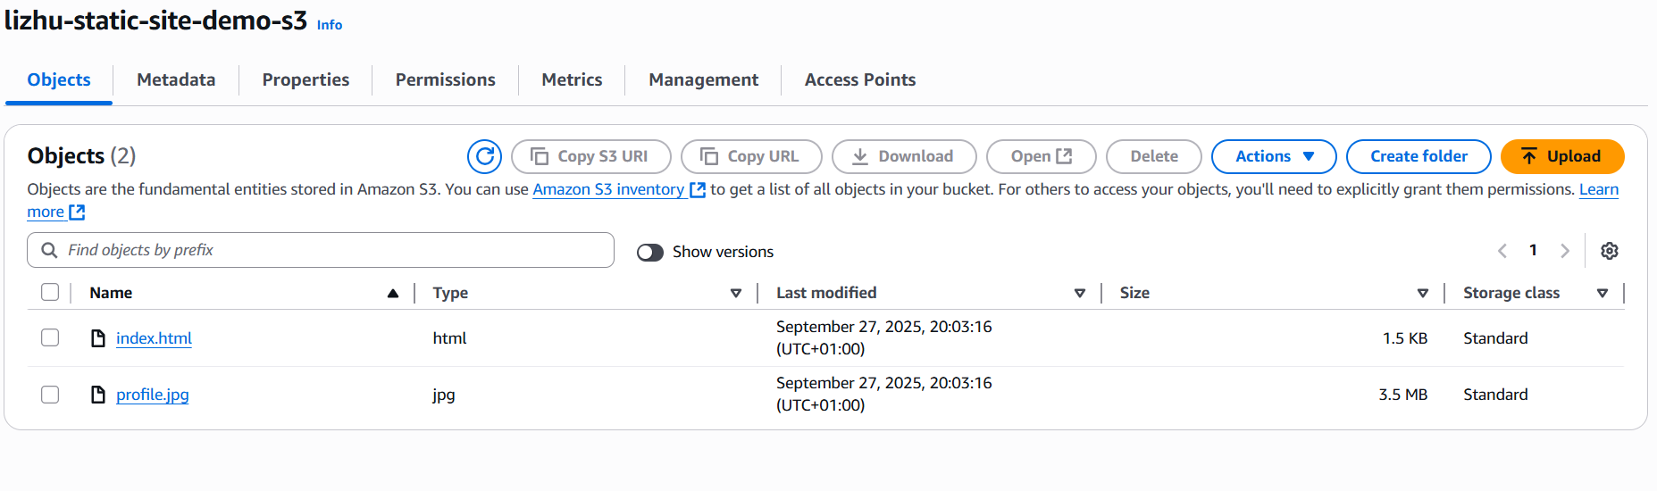

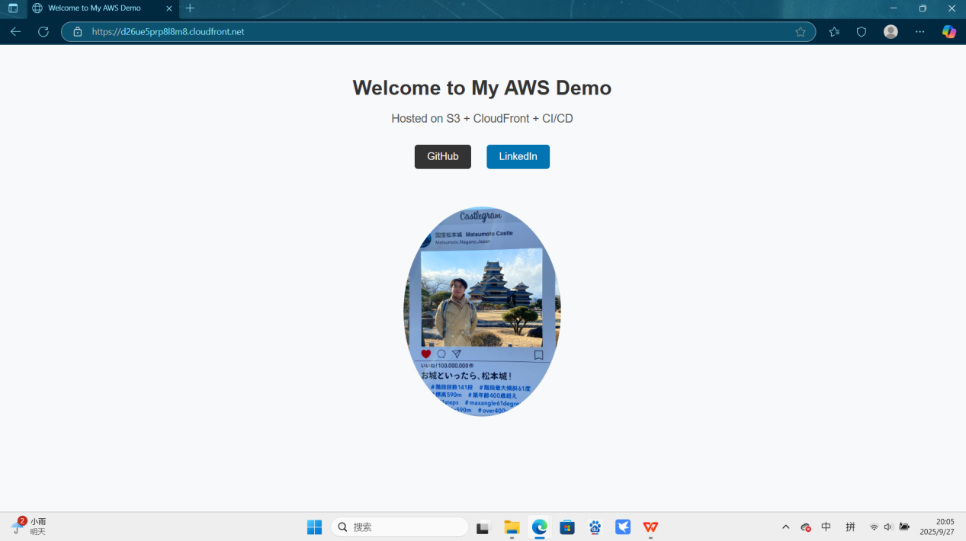

7. Create CodePipeline

Update the CodeBuild project with build commands that generate build artifacts for the Deploy stage.

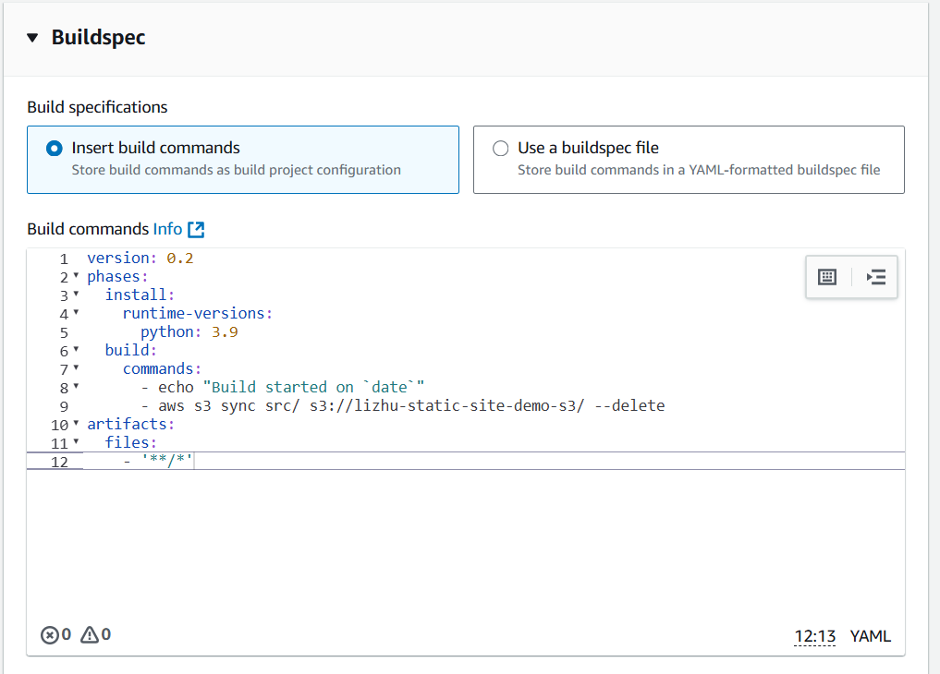

Create the CodePipeline with three stages:

- Source (GitHub) - Trigger: push events.

- Build (CodeBuild) - Uses the updated CodeBuild project.

- Deploy (S3) - Deploys artifacts to the Deploy Bucket.

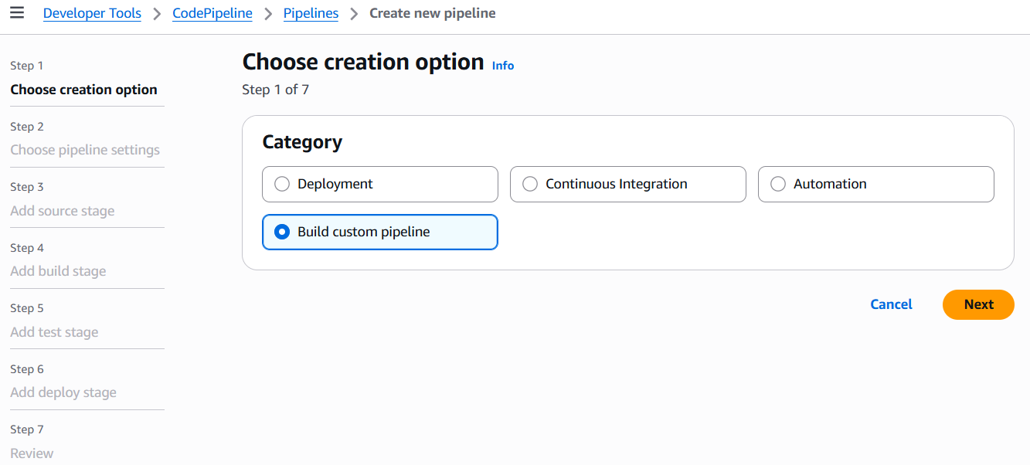

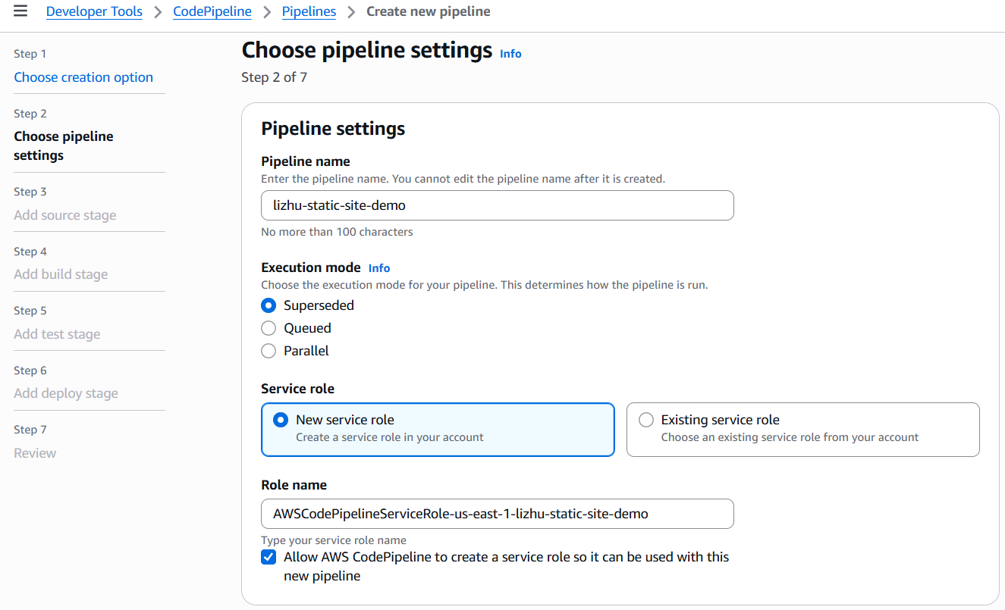

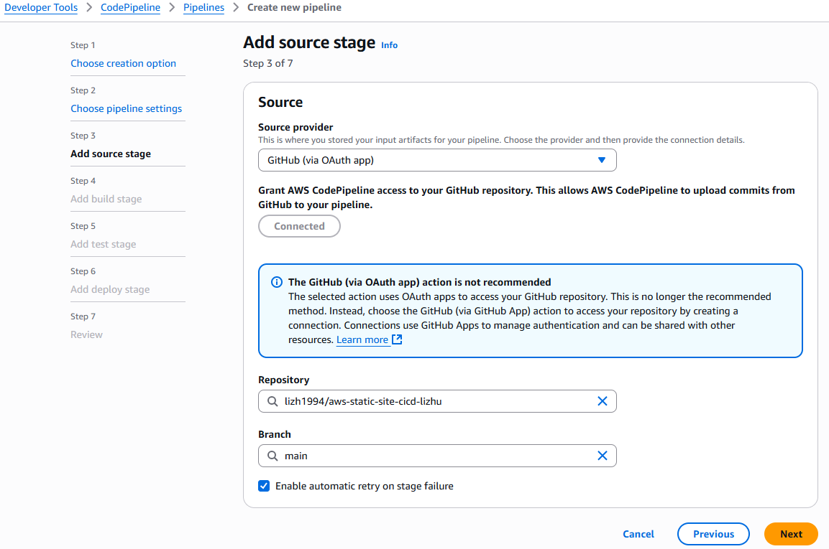

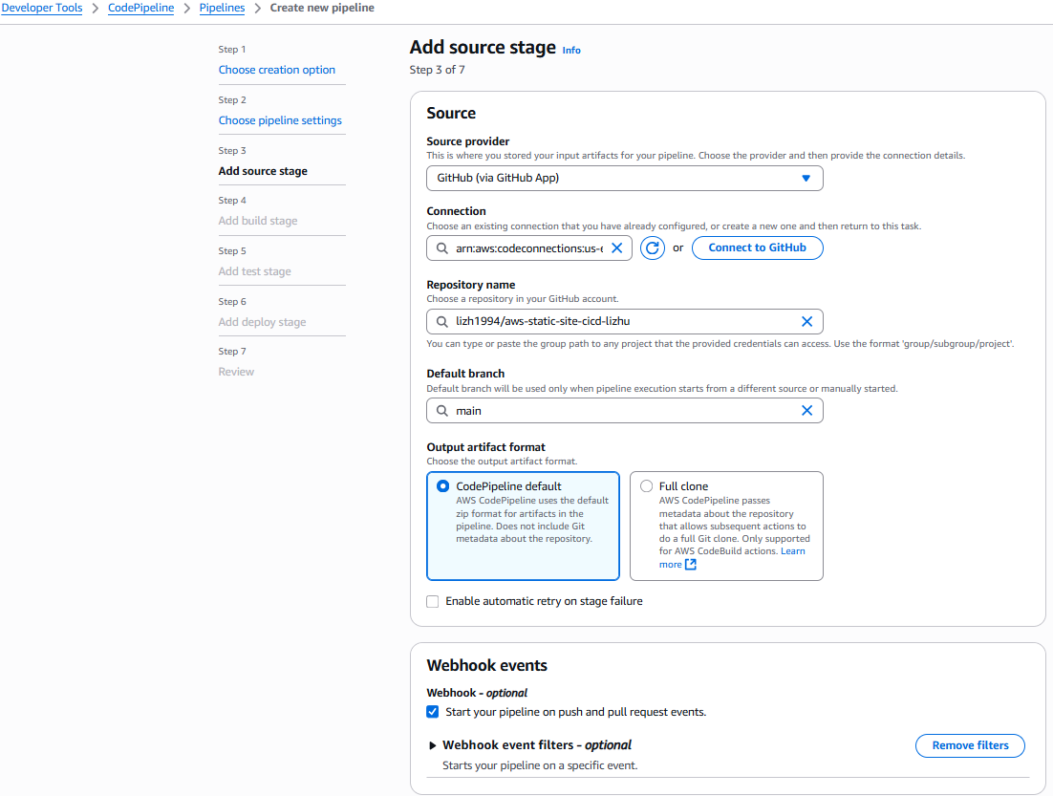

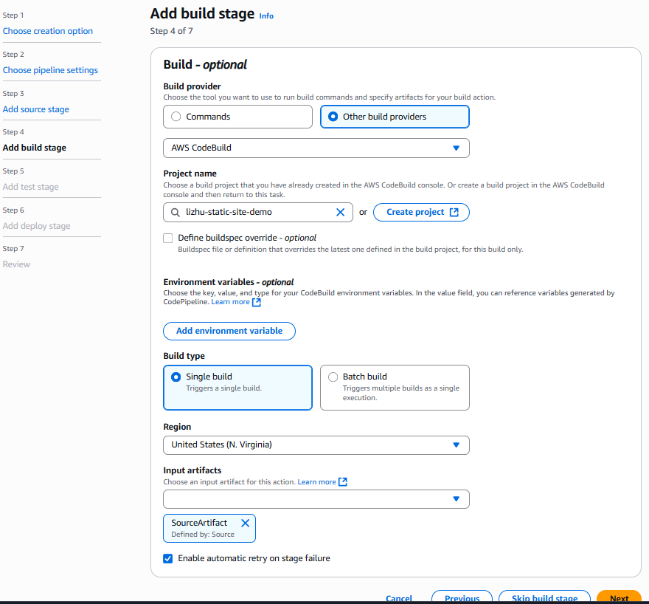

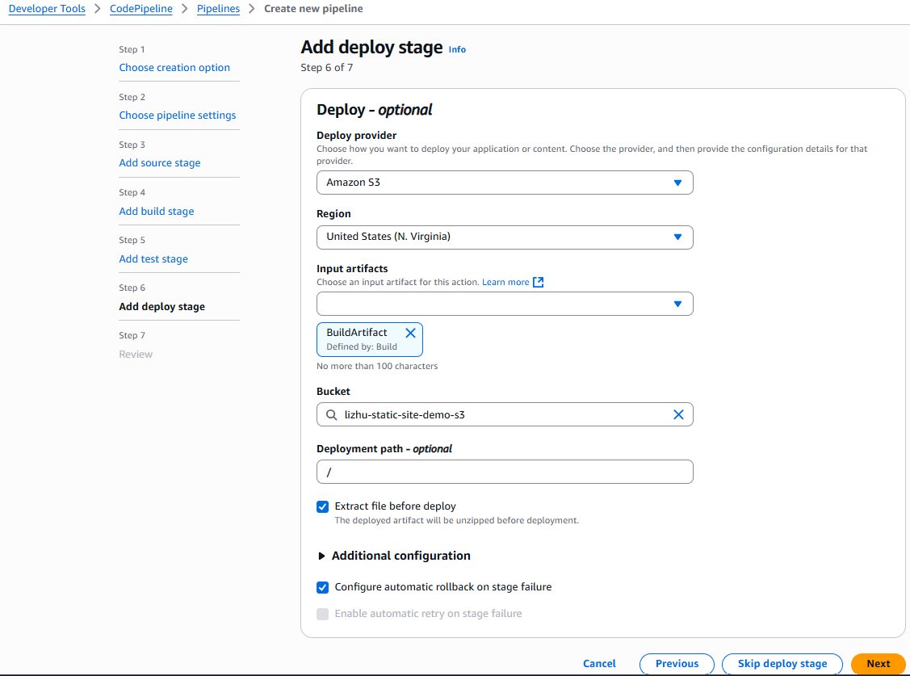

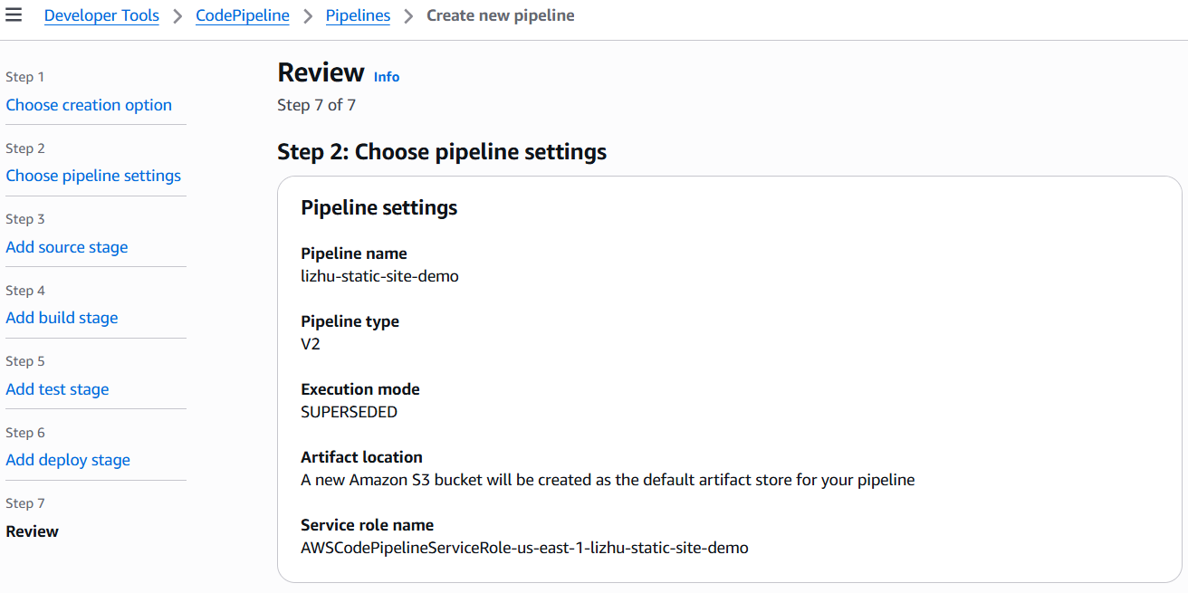

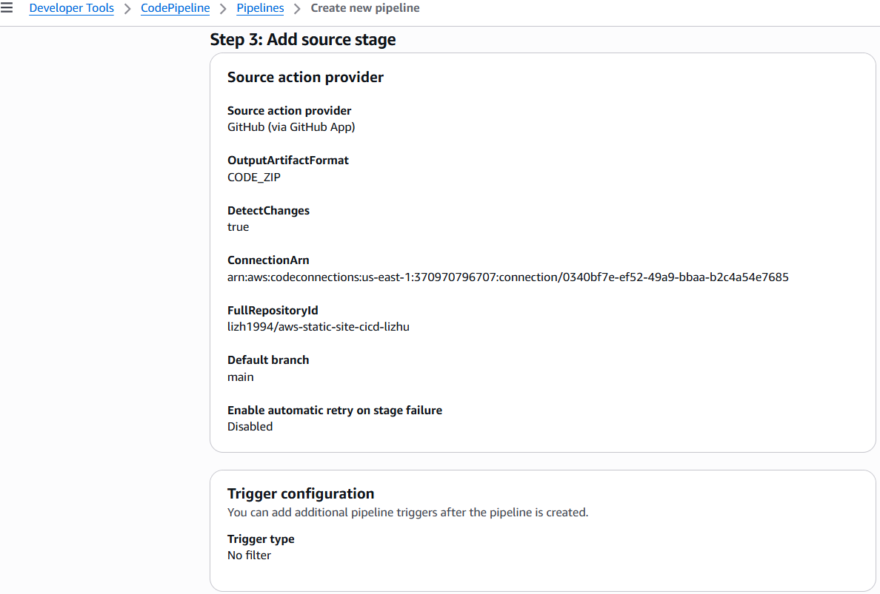

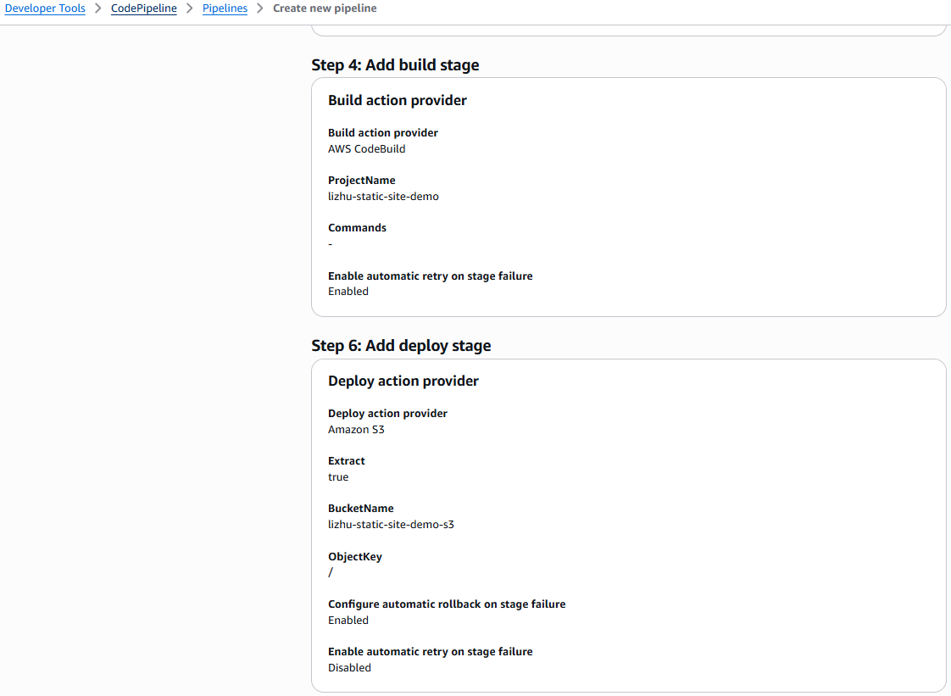

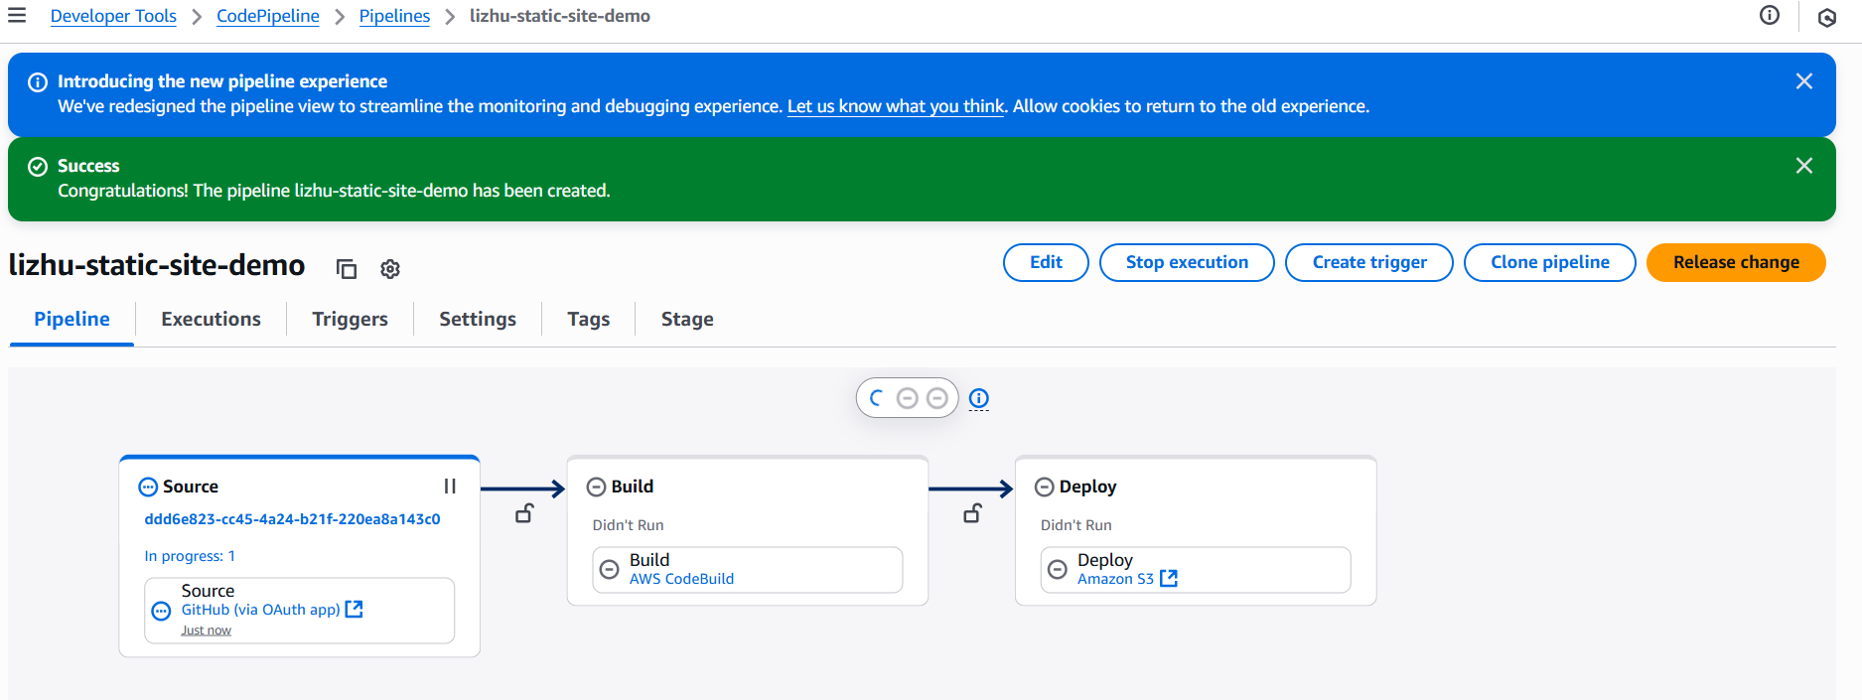

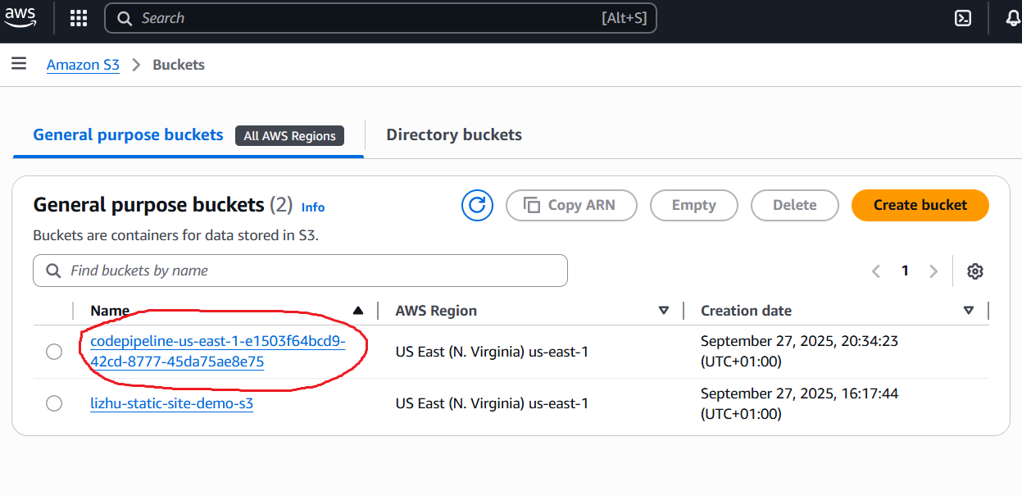

**Note**: Pipeline Artifact Bucket was automatically created by AWS to handle intermediate artifacts.

8. Troubleshooting

The first pipeline execution will always fail because the pipeline artifact bucket is just created, and the CodeBuild role does not yet have permissions for it.

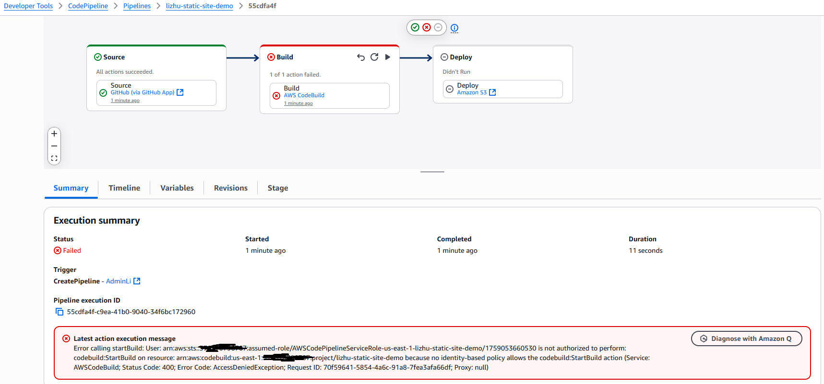

Step 1: Fix Initial Failure

- Go to the CodeBuild IAM Role.

- Add permissions for the newly created pipeline artifact bucket (Read/Write/List).

- Save and re-deploy the pipeline.

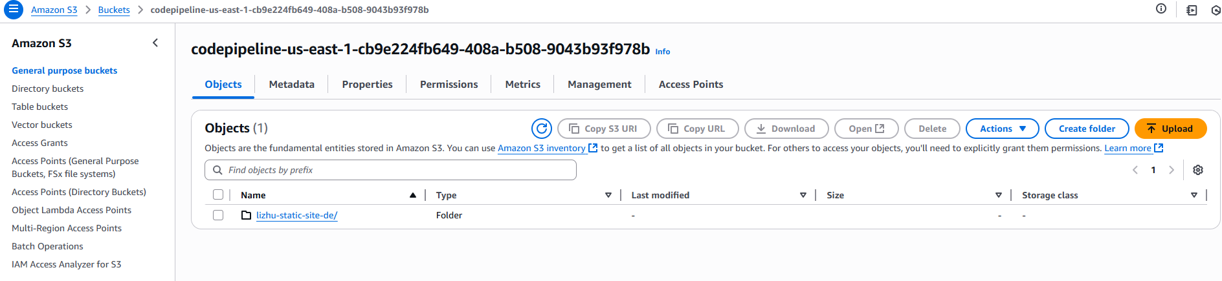

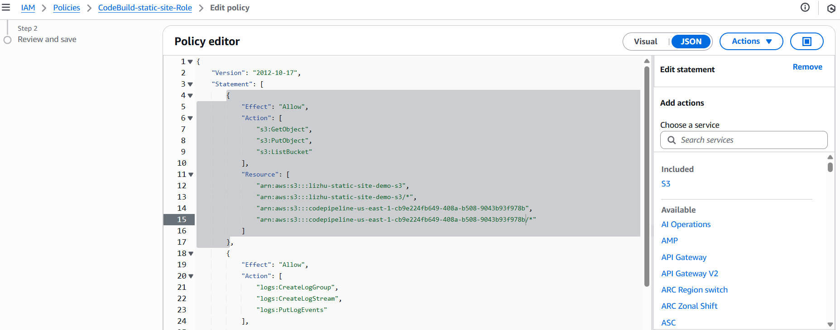

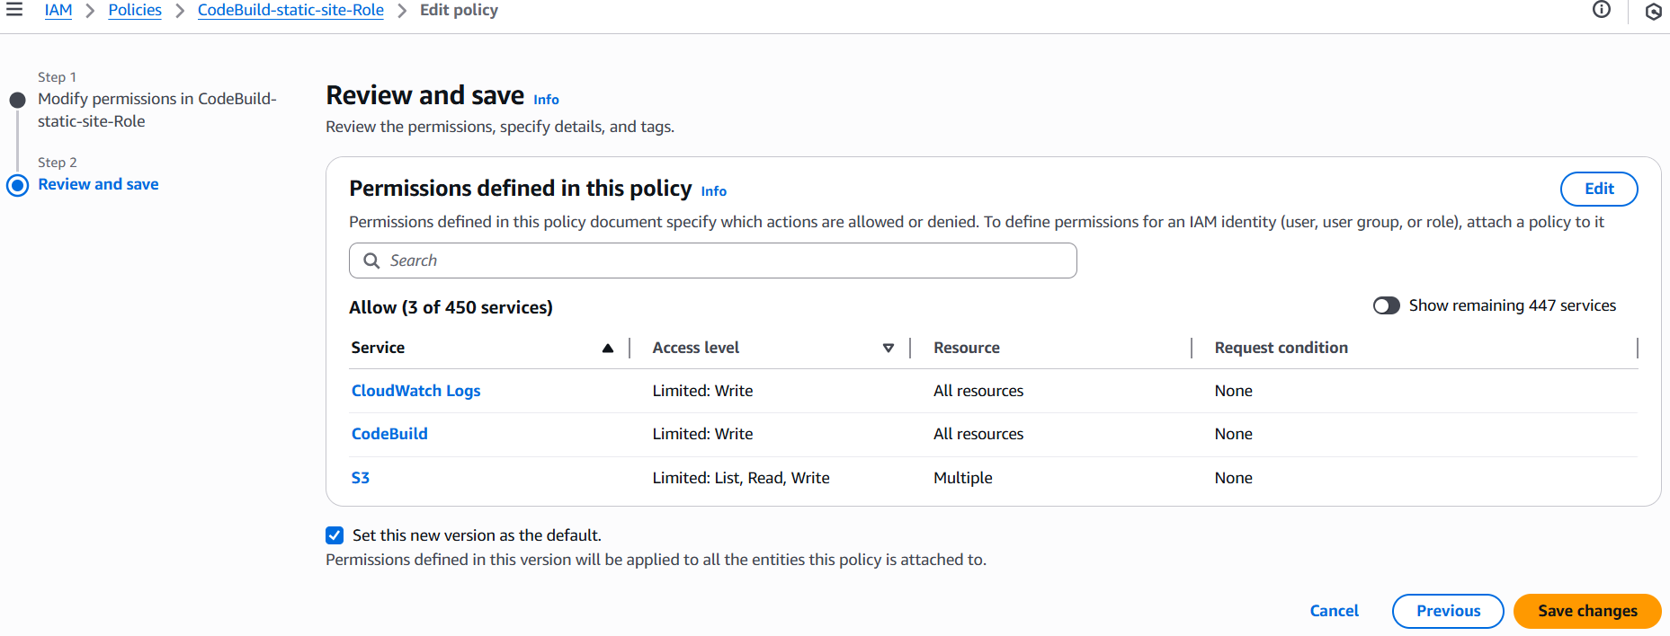

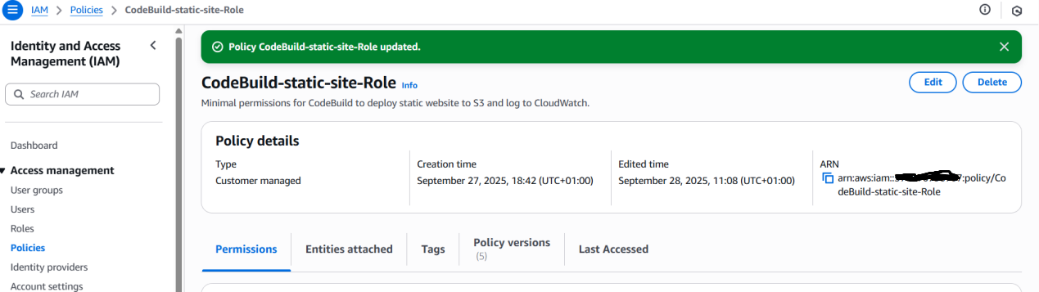

Step 2: If Issues Persist

- CodeBuild permissions: Ensure the role includes full access (Get/Put/Delete/List) to the deploy S3 bucket and necessary access to the pipeline bucket.

- CodePipeline permissions: If the pipeline cannot pass artifacts between stages, add an inline policy to the CodePipeline role with the required s3:* actions on the artifact bucket.

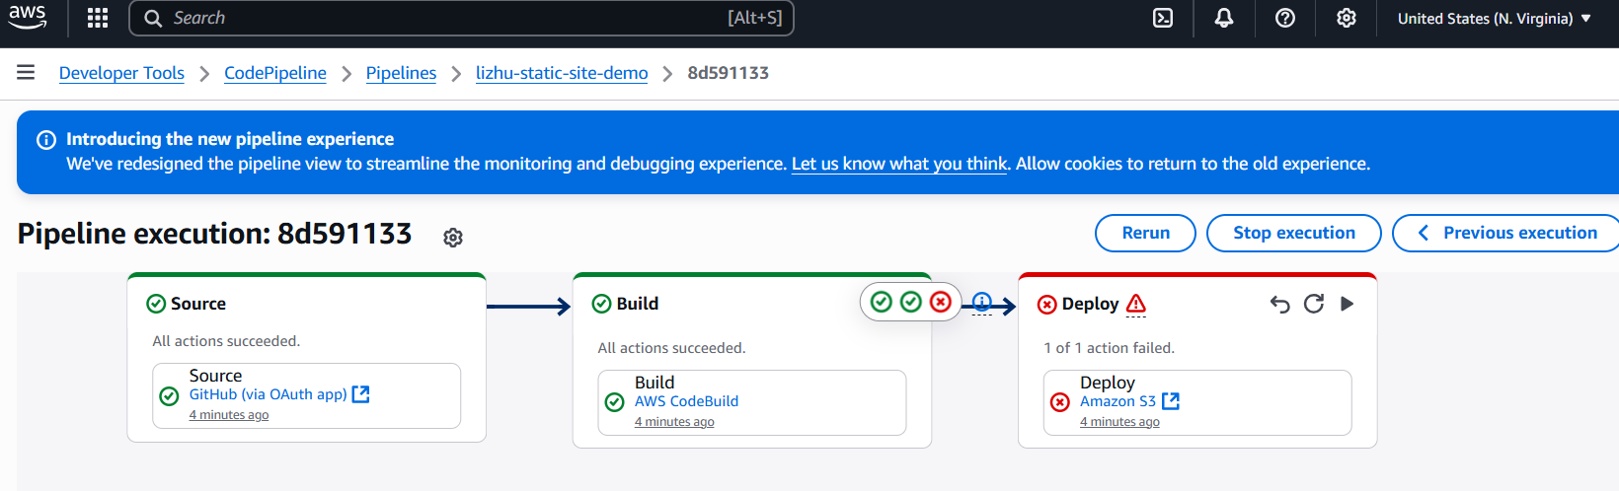

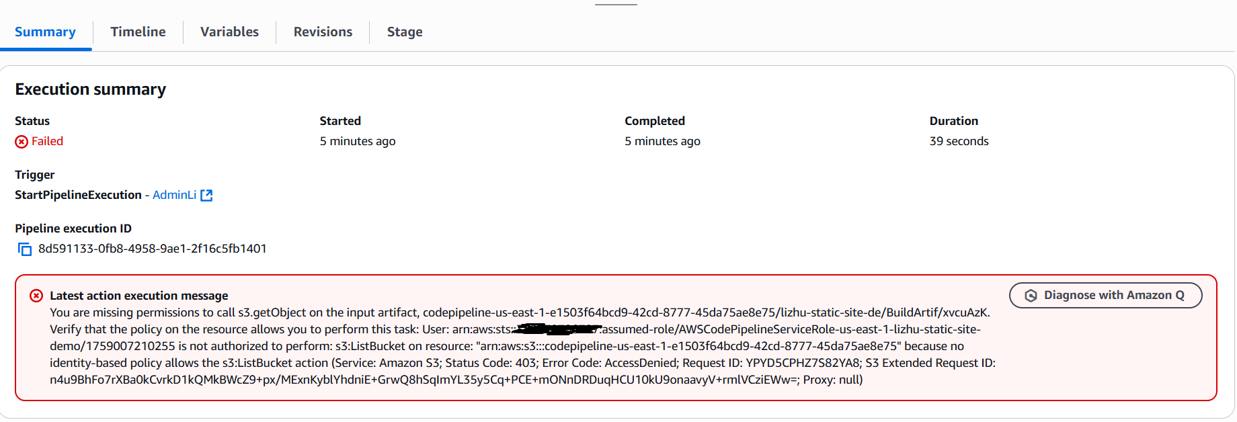

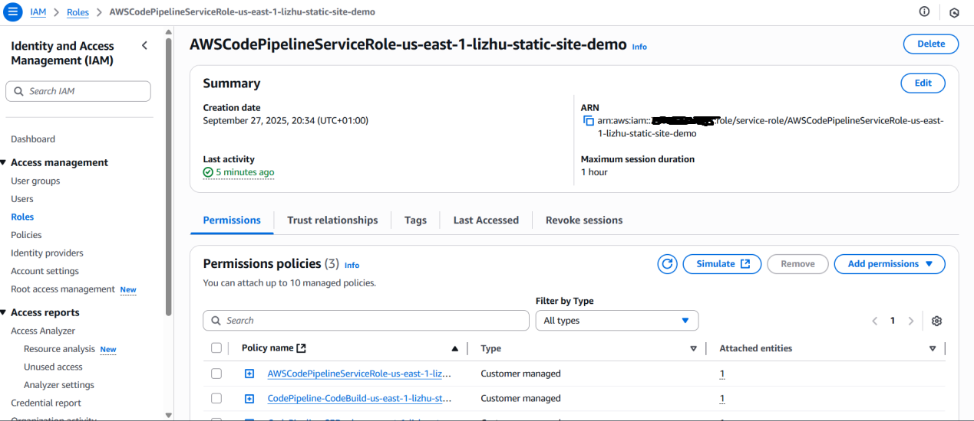

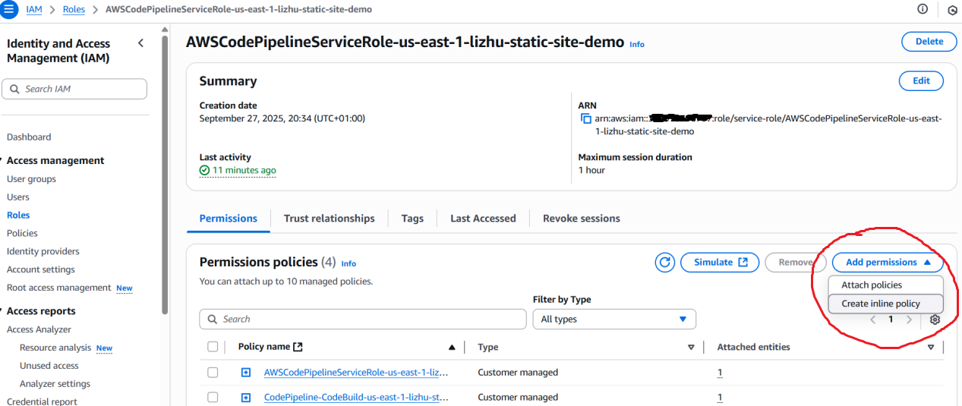

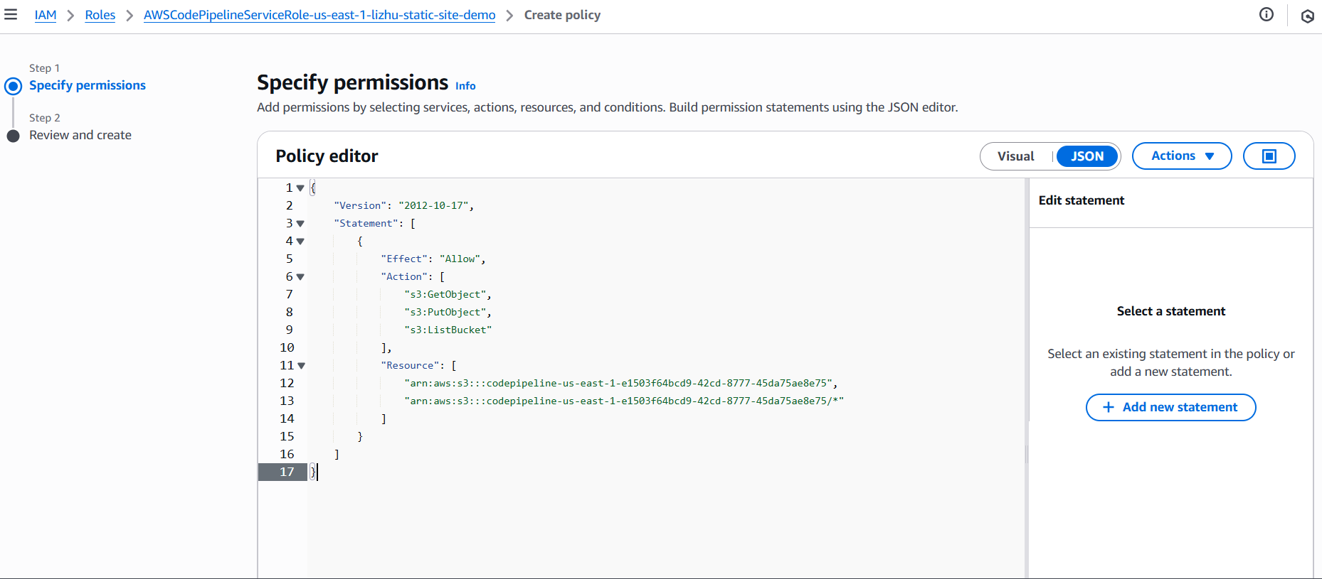

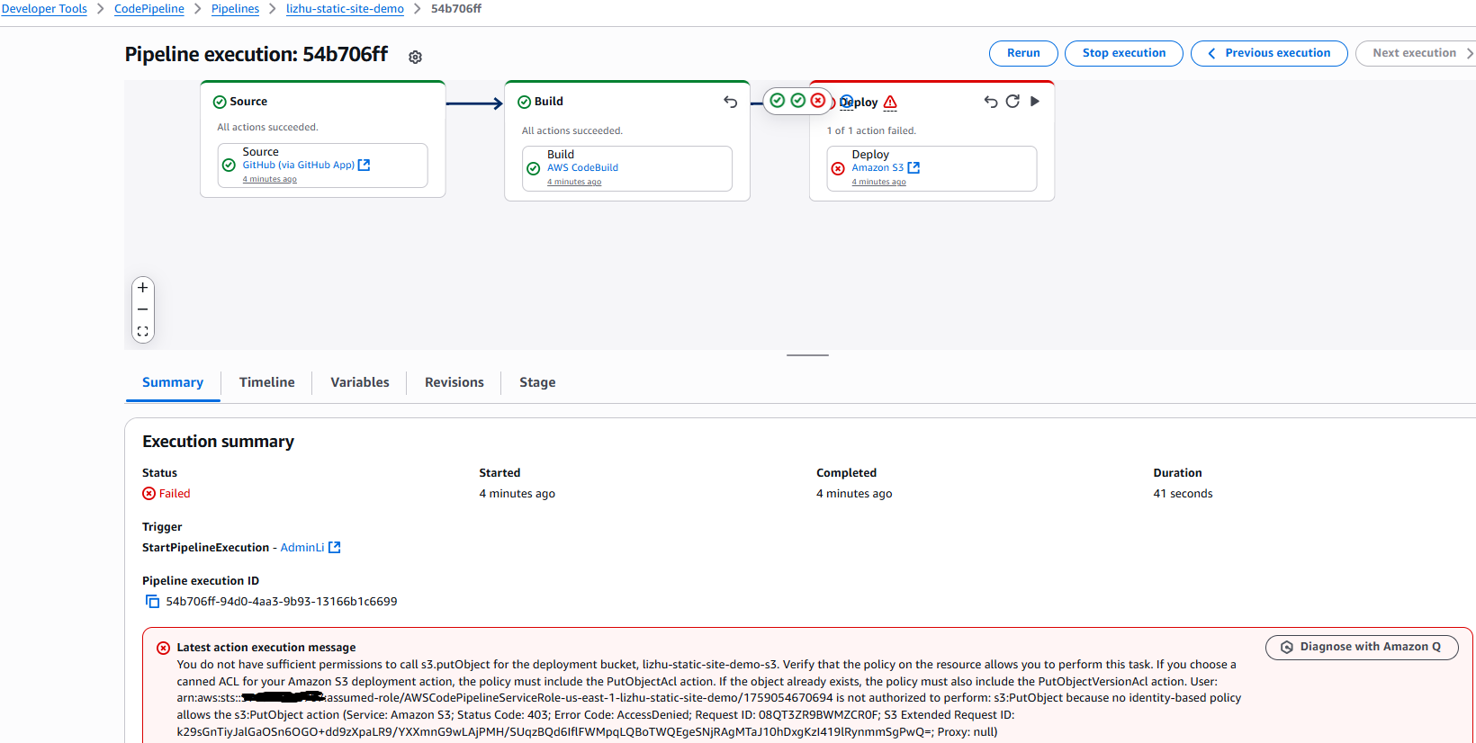

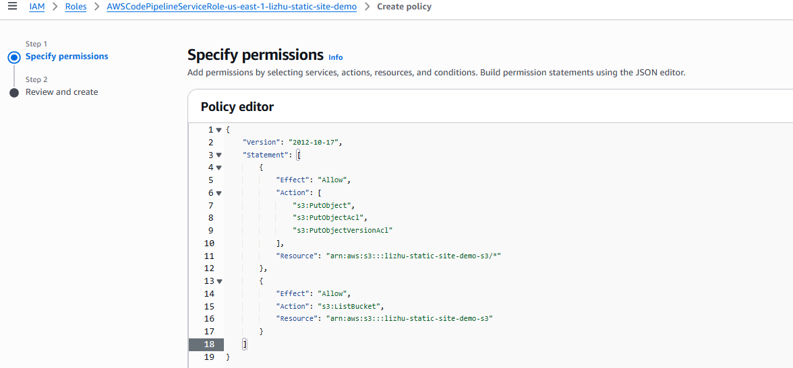

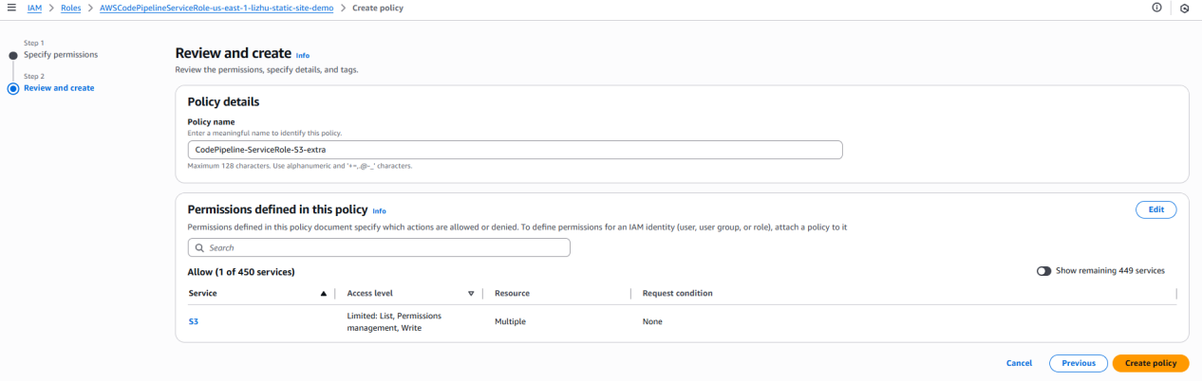

Most failures at this stage are caused by IAM misconfigurations or artifact exchange issues between services.

9. Validate Deployment

After successful deployment, test the CloudFront distribution to confirm site updates.

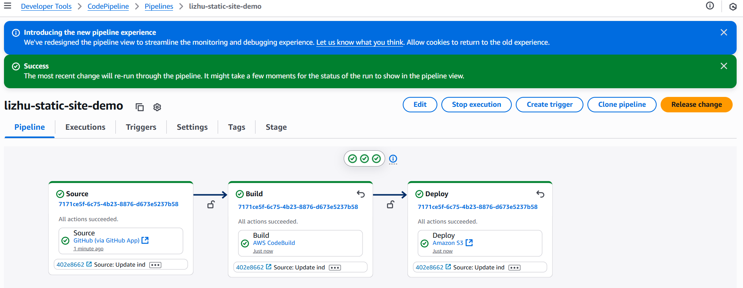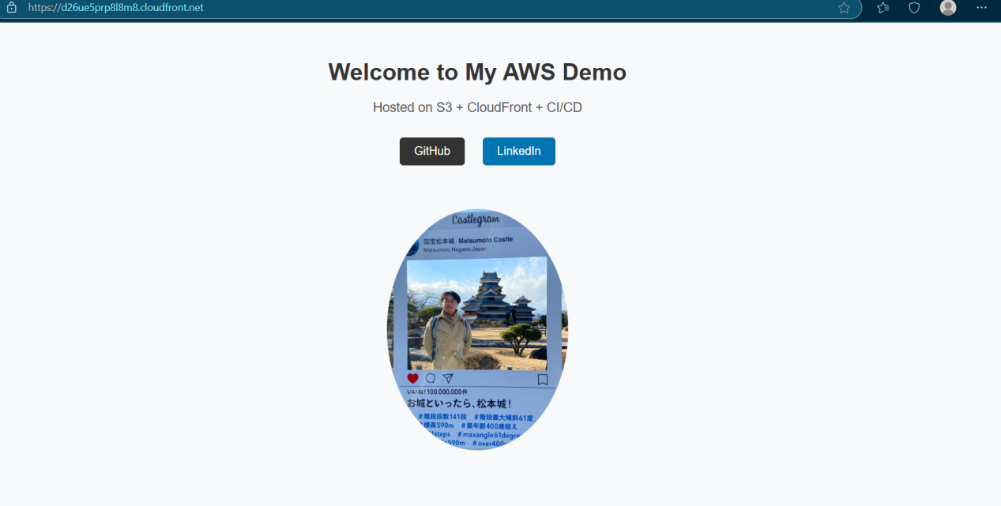

Modify index.html, commit the change to GitHub, and confirm the pipeline automatically redeploys the updated version. I replaced LinkedIn by Wikipedia, and you can find in the following screenshots the website changed.



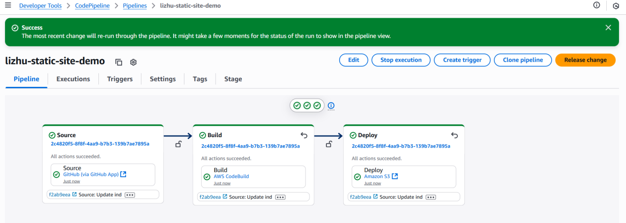

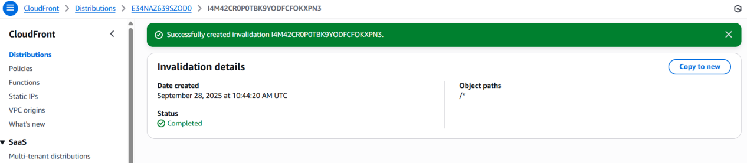

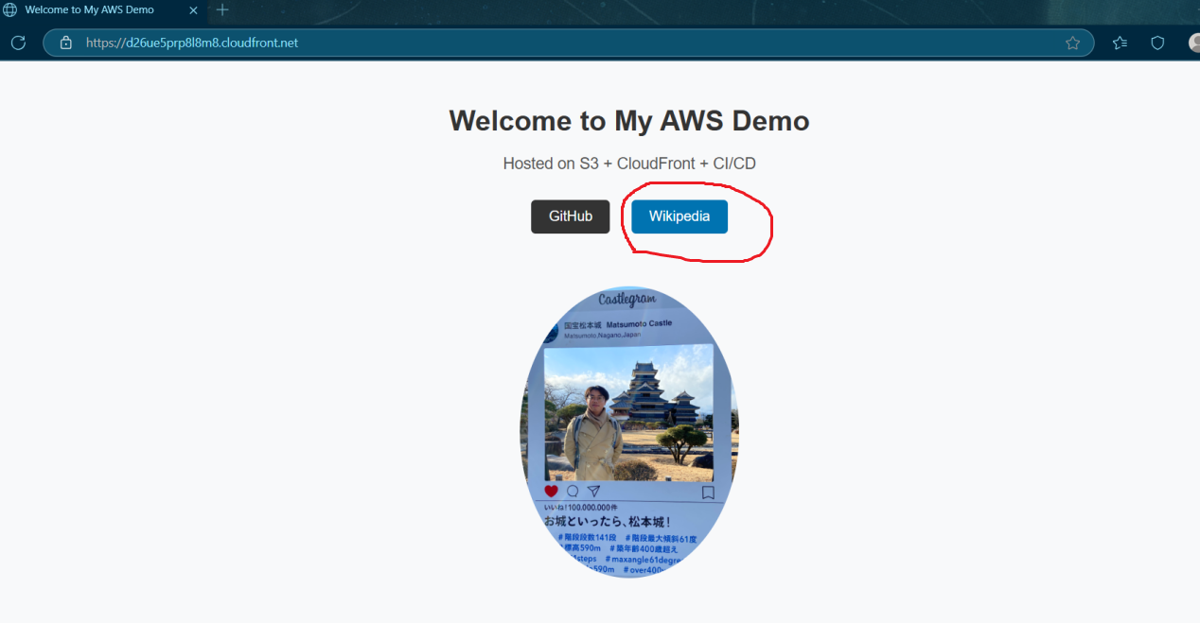

10. Add Monitoring & Notifications

Create an SNS Topic and subscribe a personal email.

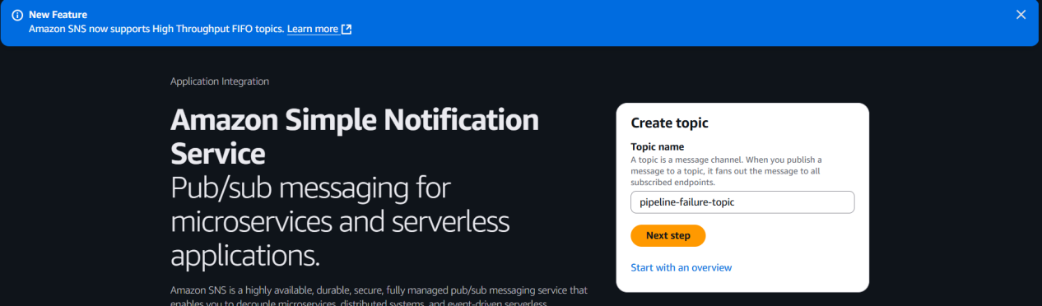

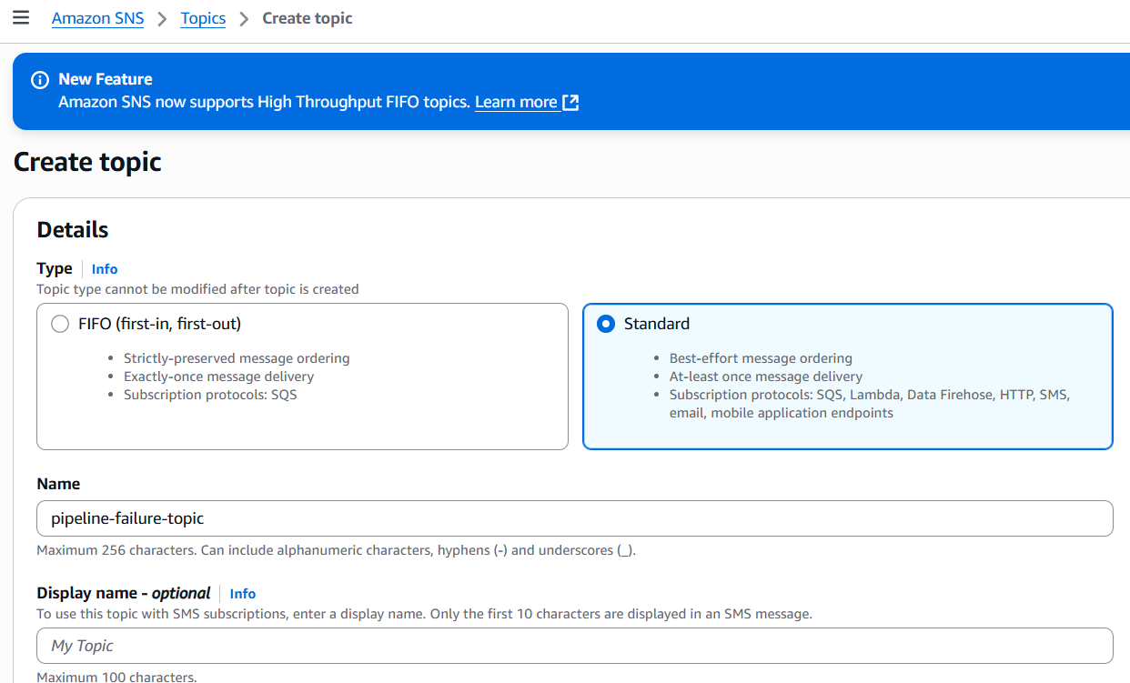

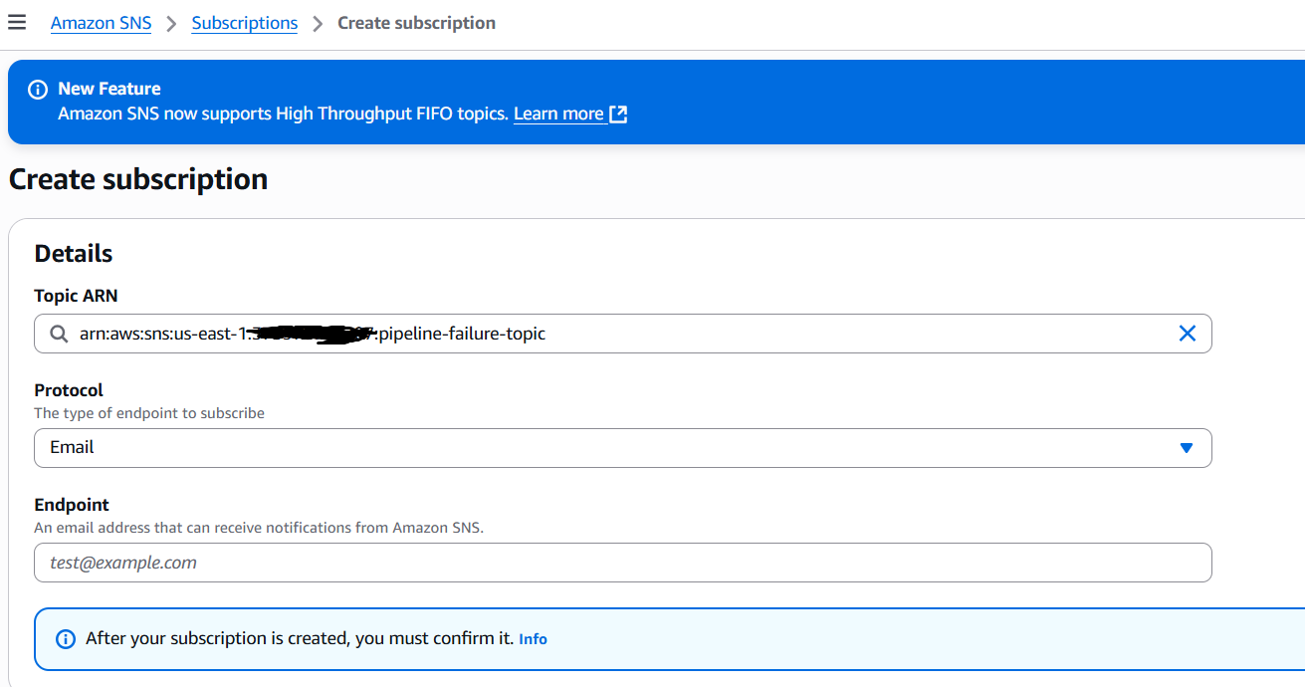

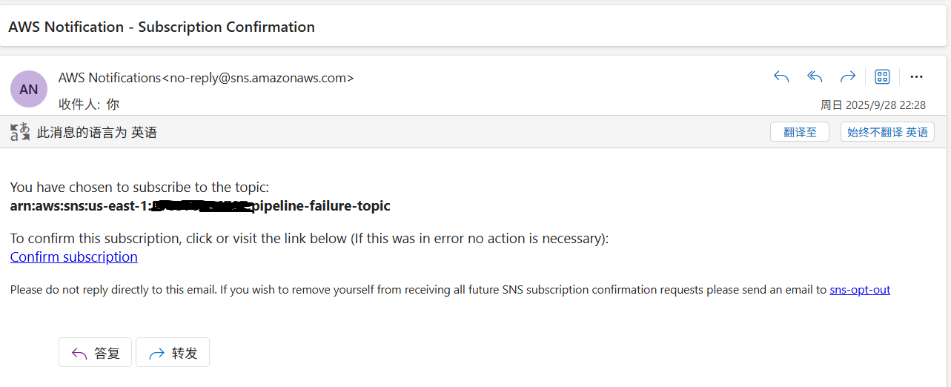

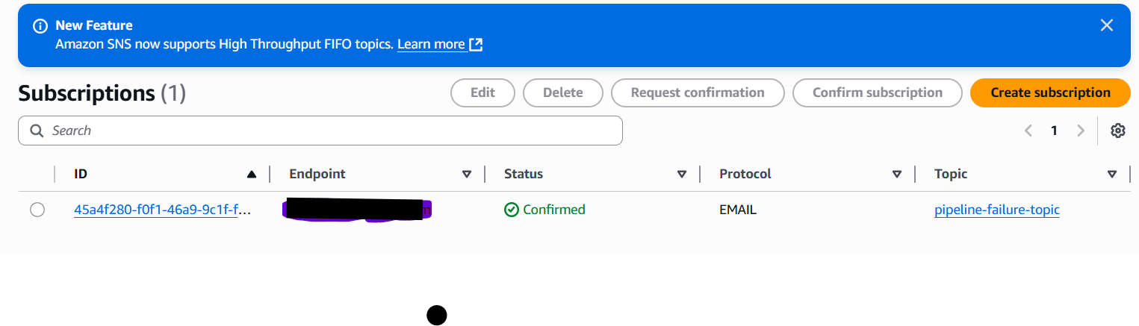

Set up EventBridge to detect pipeline failure events.

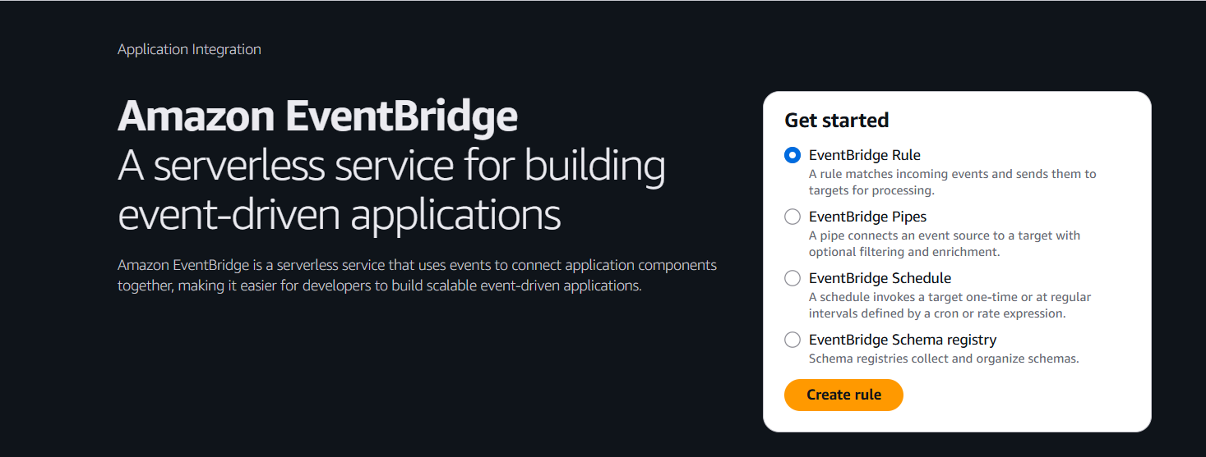

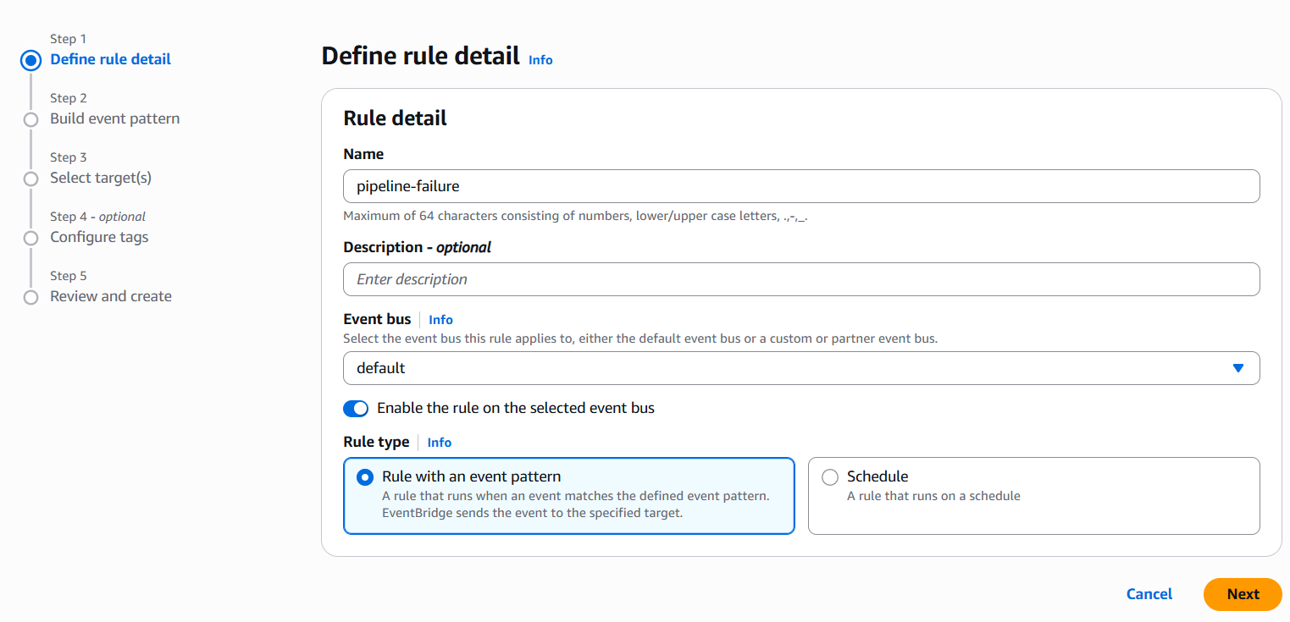

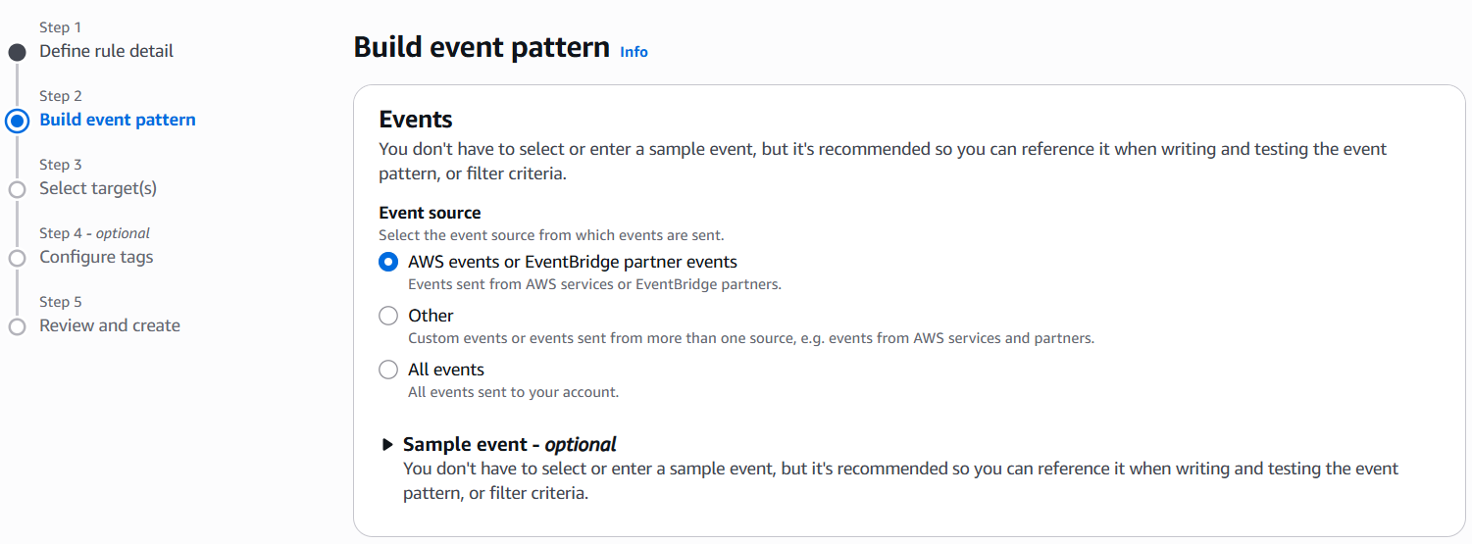

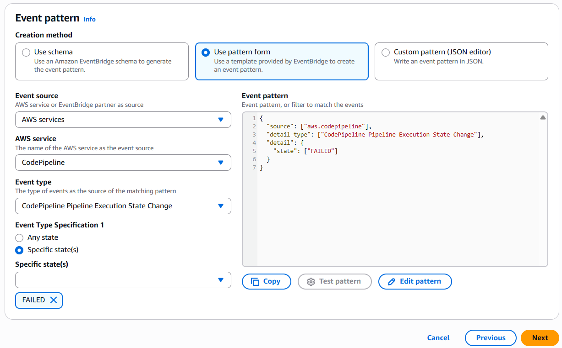

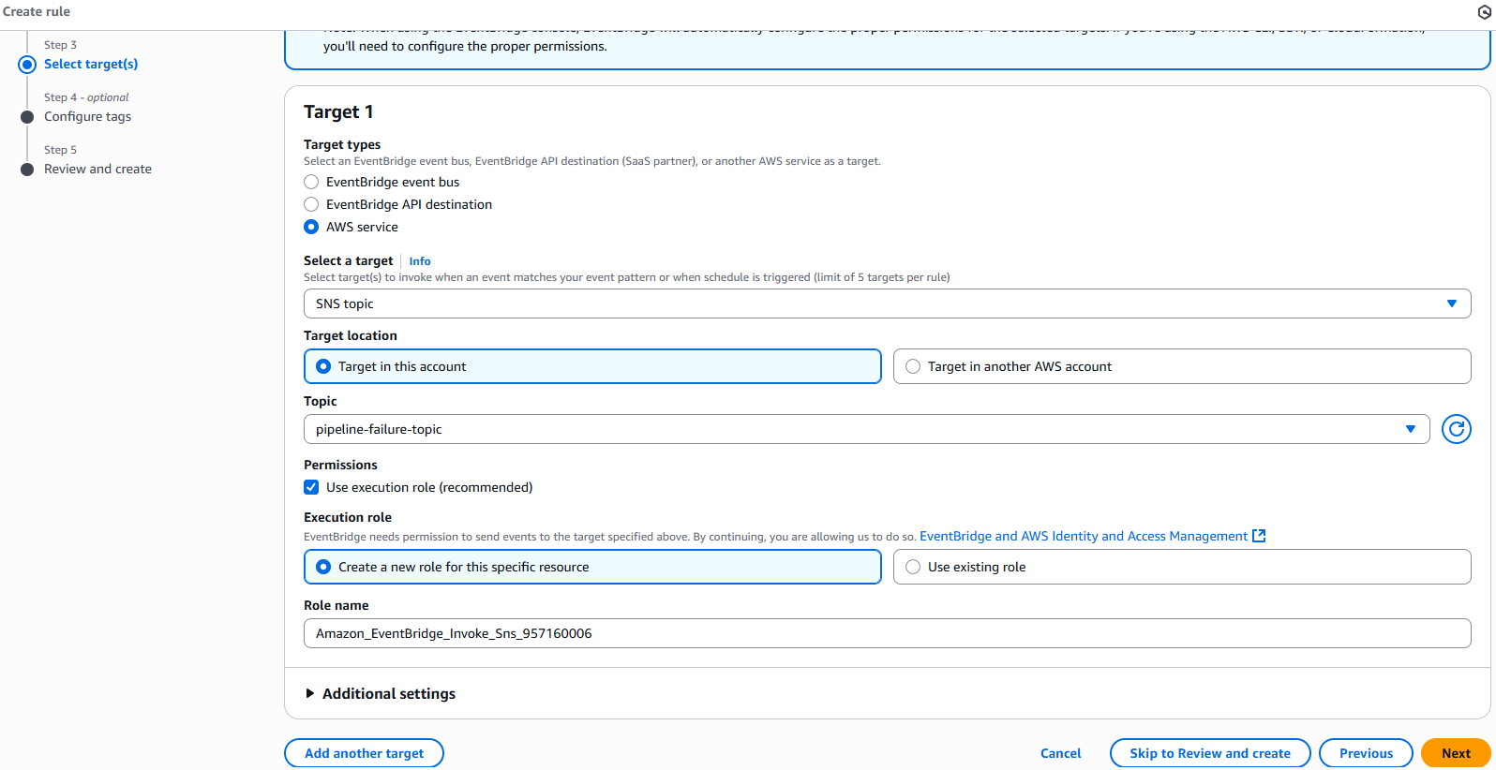

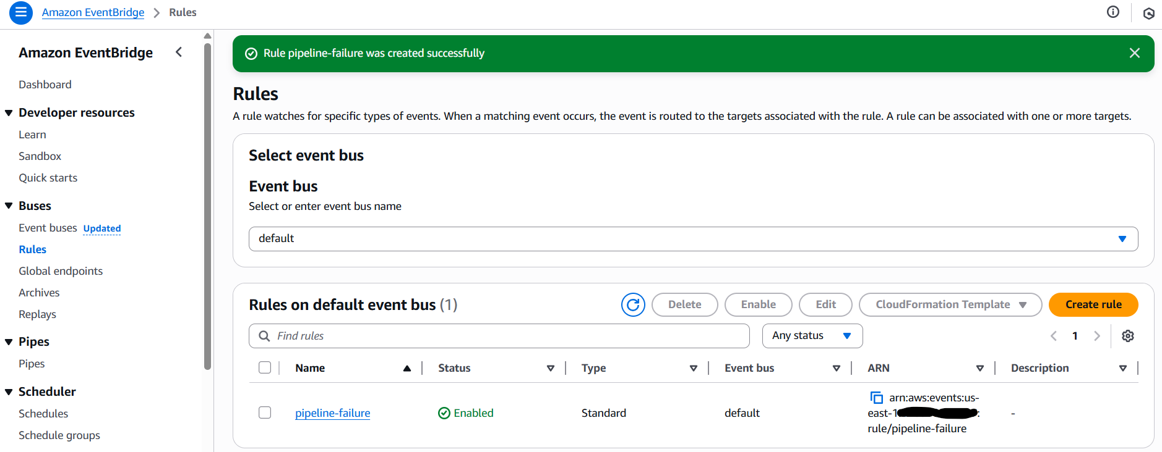

Tested by intentionally breaking IAM permissions, I removed the s3:DeleteObject here → confirmed alert email was received.

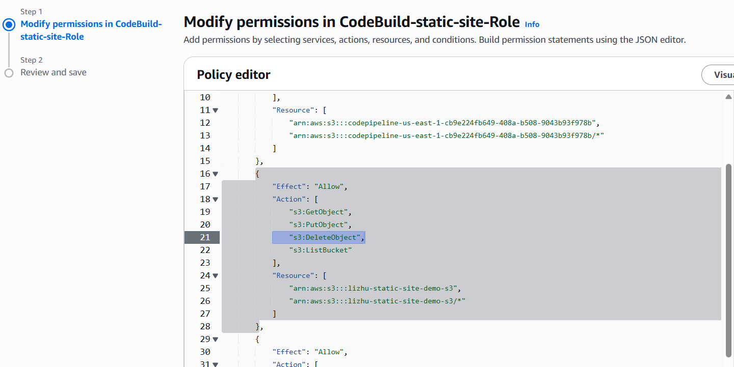

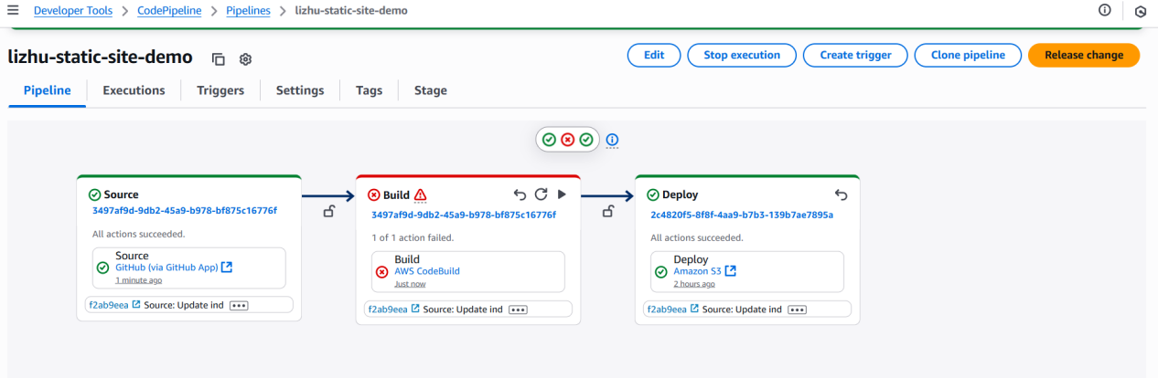

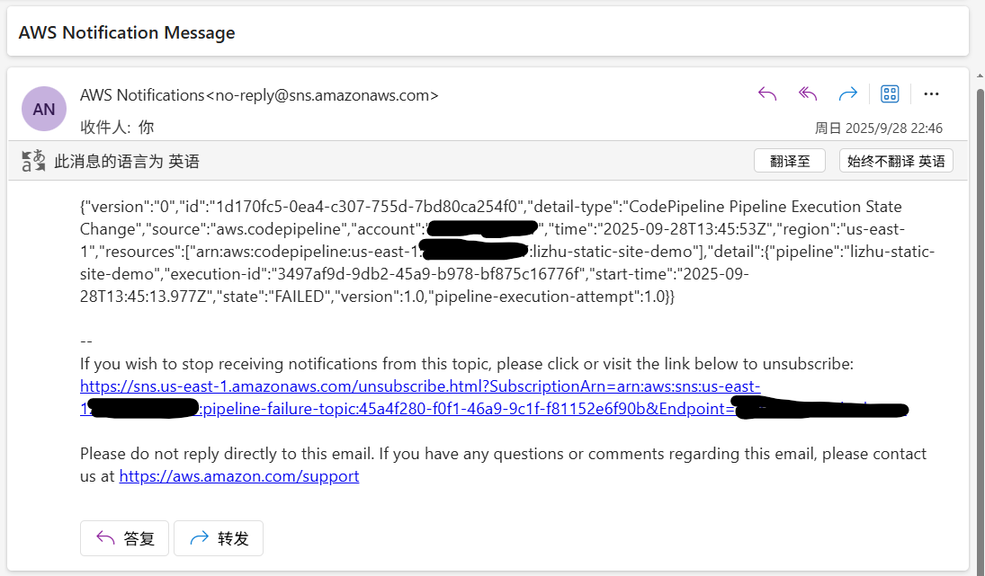

11. Lessons Learned

**11. 1 IAM Permissions**

During the project, I gained a much clearer understanding of how IAM roles and policies work. Striking the right balance between least privilege and task feasibility is essential:

- Roles must be granted just enough access to complete their tasks, but not more.

- This requires knowing exactly what each AWS service will do, and how it interacts with others.

- Permissions must also be scoped at the right level of granularity.

Many of my initial failures were caused by insufficient permissions. These issues forced me to gradually clarify the boundaries of each role’s access, which deepened my understanding of IAM in practice.

**11. 2 Troubleshooting Skills**

This was my first time building an AWS demo project end-to-end, so failures were frequent. Through this process I learned how to:

- Read error logs carefully.

- Identify the root cause by correlating logs with service behavior.

- Apply targeted fixes instead of random trial and error.

Learning to debug AWS services systematically has been one of the most valuable outcomes of this project.

**11. 3 Service Interactions**

Another key lesson was to always map out how services exchange data and interact with each other. Missing or unclear interactions often caused failures.

For example, in my first pipeline runs the deploy stage failed repeatedly. After verifying permissions, I realized the real problem was that the build stage never produced a build artifact output. Without that artifact, CodePipeline could not hand anything over to the deploy stage.

Understanding these service interactions up front prevents wasted effort and unnecessary debugging.

**Final Reflection**

**Most importantly, this project reminded me that hands-on practice is irreplaceable. Designing demos, facing failures, and solving problems along the way provided insights no tutorial could give me.**

**The key is to practice with curiosity, ask questions when things break, and keep the mindset that failure is part of the learning process.**